

DPB0.0 Application Checkout Guide

|  |  |
| --- | --- |
| **Version:** | 0.3 |
| **Status:** | Draft |
| **Document Owner:** | Front-End Squad |
| **Document Prepared By :** | Ramkumar KB |
| **Published Date:** | 15/11/2014 |

*No disclosure or use of this document may be made without the prior written consent of CREDIT SUISSE.*

Contents

1 Overview 4

2 T&C Acceptance 5

3 Login Page 6

4 2FA 7

5 Home Page 8

6 Portfolio – All Positions 10

7 Portfolio – Liquidity 11

8 Portfolio - Performance 12

9 Portfolio - Transactions 13

10 Portfolio – Income & Expenditure 14

11 Portfolio – Asset Allocation 15

12 Portfolio – Currency Allocation 16

13 Portfolio – All Positions (All Asset Class) 17

14 Portfolio – All Positions (Filtered by Asset Class) 18

15 Markets – Currencies 19

16 Markets – Bonds 20

17 Markets – Commodities 21

18 Markets – News Summary 22

19 Markets – News Detail 23

20 Watchlist – List View 24

21 Watchlist – Grid View 25

22 Search Instrument 26

23 Ideas – Home 27

24 Ideas – Products By 28

25 Ideas – Products (Investment Themes) 29

26 Ideas – Product Types 30

27 Ideas – Recommended Ideas 31

28 Ideas – Products 32

29 Ideas – Instrument details 33

30 Ideas – By Strategy & Research 34

31 Filter Ideas 35

32 Ideas – PDF Report 36

33 Trade – Landing Page, with Buying Power 37

34 Trade – Equity, with Fit-for-Trade 38

35 Trade – Equity Calendar 39

36 Trade – FX, with Fit-for-Trade 40

37 Collaboration - Home 41

38 Collab – Screen Sharing with Cafex 42

38.1 Client Side 42

38.2 RM Side 42

39 Logout 43

40 Inactivity Period and Auto-logout 44

41 Splunk / Analytics 45

# Overview

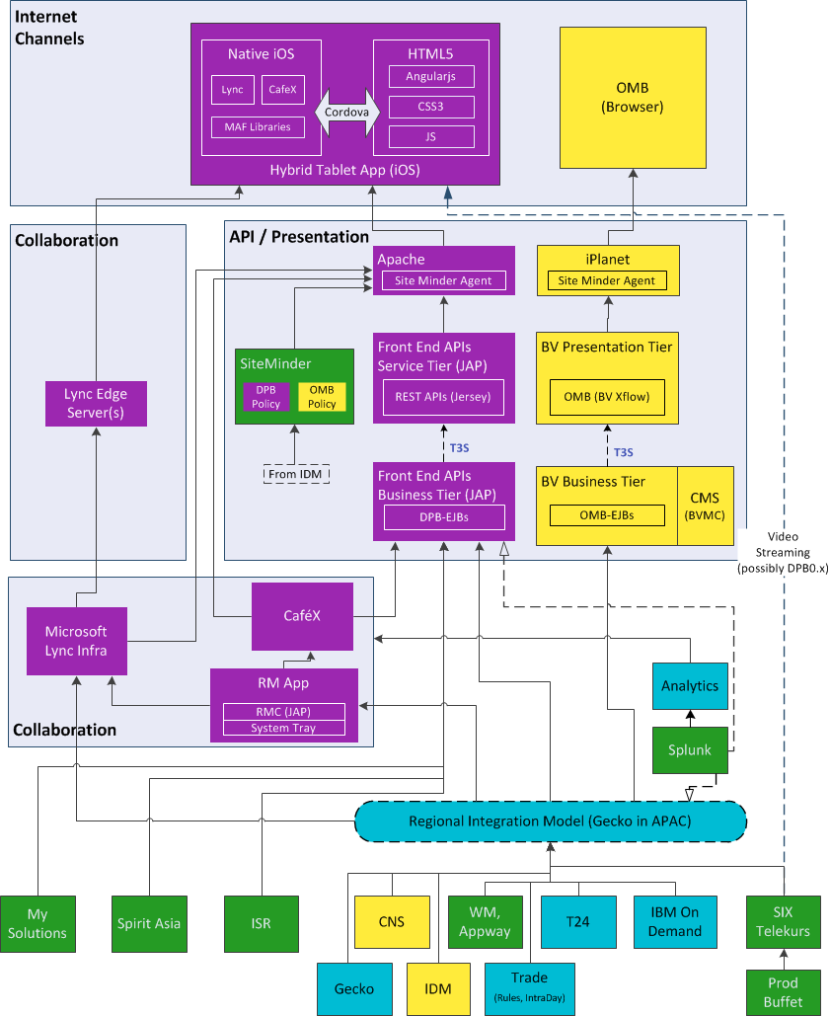

**70 APIs**

**99 APIs**

# T&C Acceptance

<TBD>

This page verifies:

|  |  |
| --- | --- |
| **Systems / JAP Components** | **Verifications** |
|  |  |
|  |  |
|  |  |
|  |  |
|  |  |

# Login Page

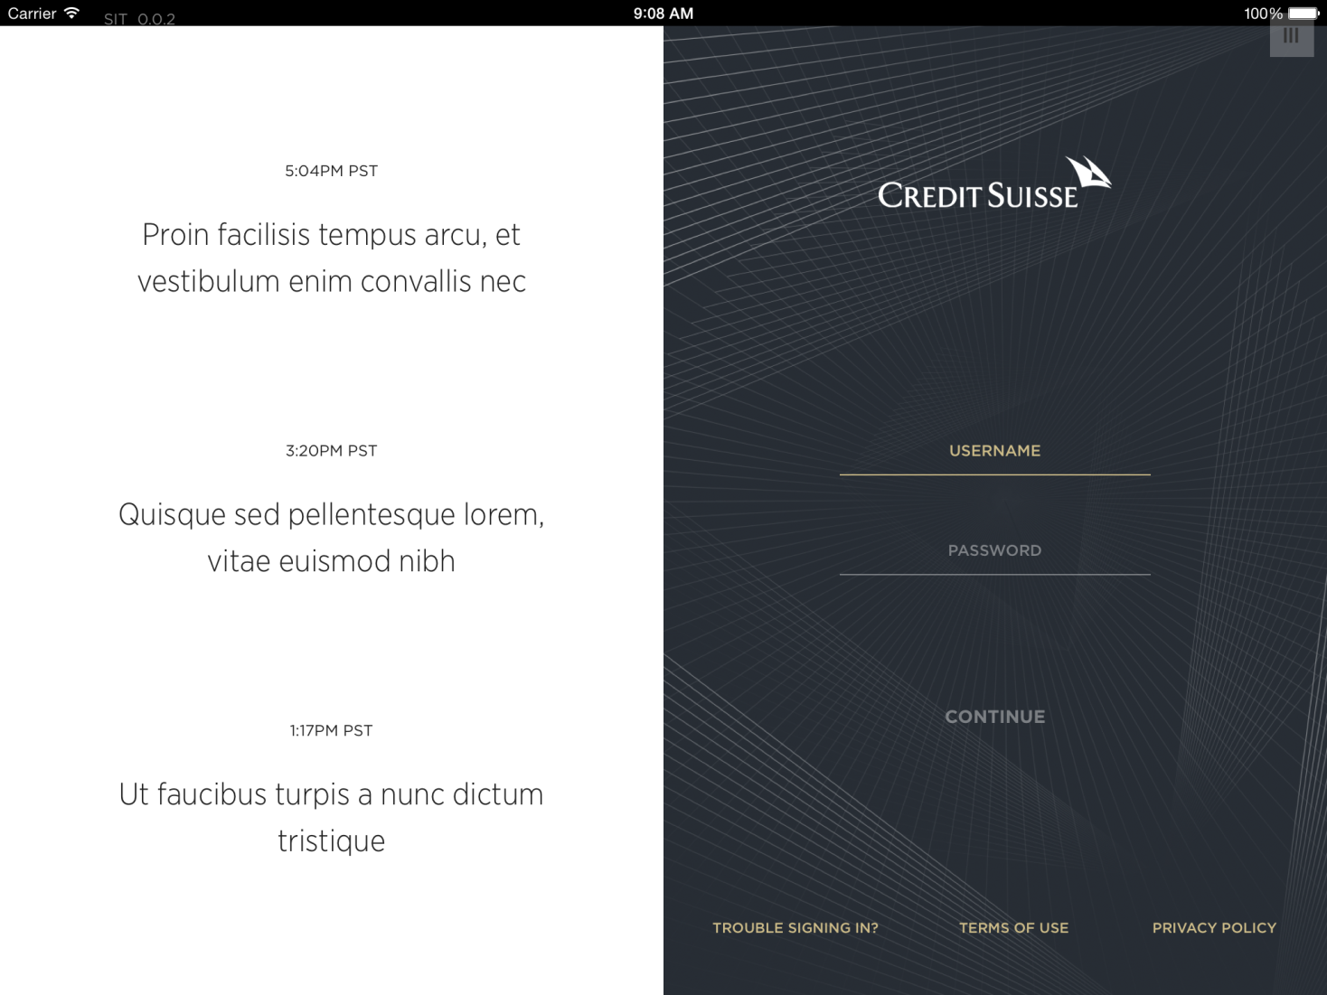

This page verifies:

|  |  |
| --- | --- |
| **Systems / JAP Components** | **Verifications** |
| UBL, UPL | User-ID created OK in the DSSS Authentication, SIX user associated successfully |
| Siteminder | 1FA part of the Security Flow with Sitminder & DSSS |
|  |  |

# 2FA

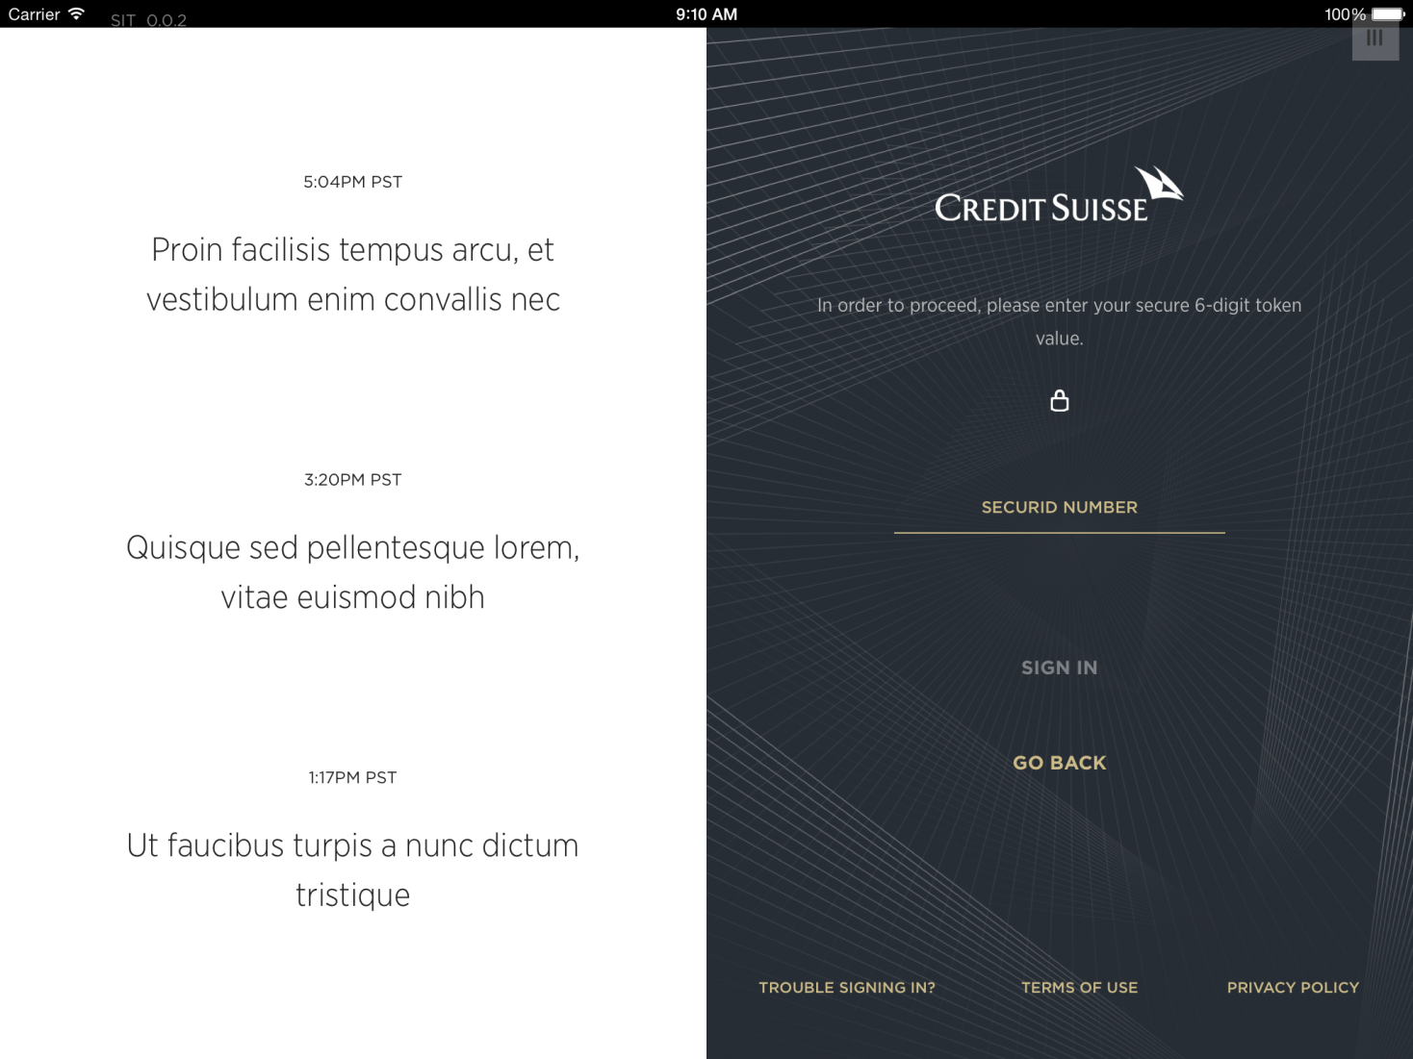

This page verifies:

|  |  |
| --- | --- |
| **Systems / JAP Components** | **Verifications** |
| Siteminder | 1FA part of the Security Flow with Sitminder & DSSS is Ok. User encryption is Ok. |
|  |  |

# Home Page

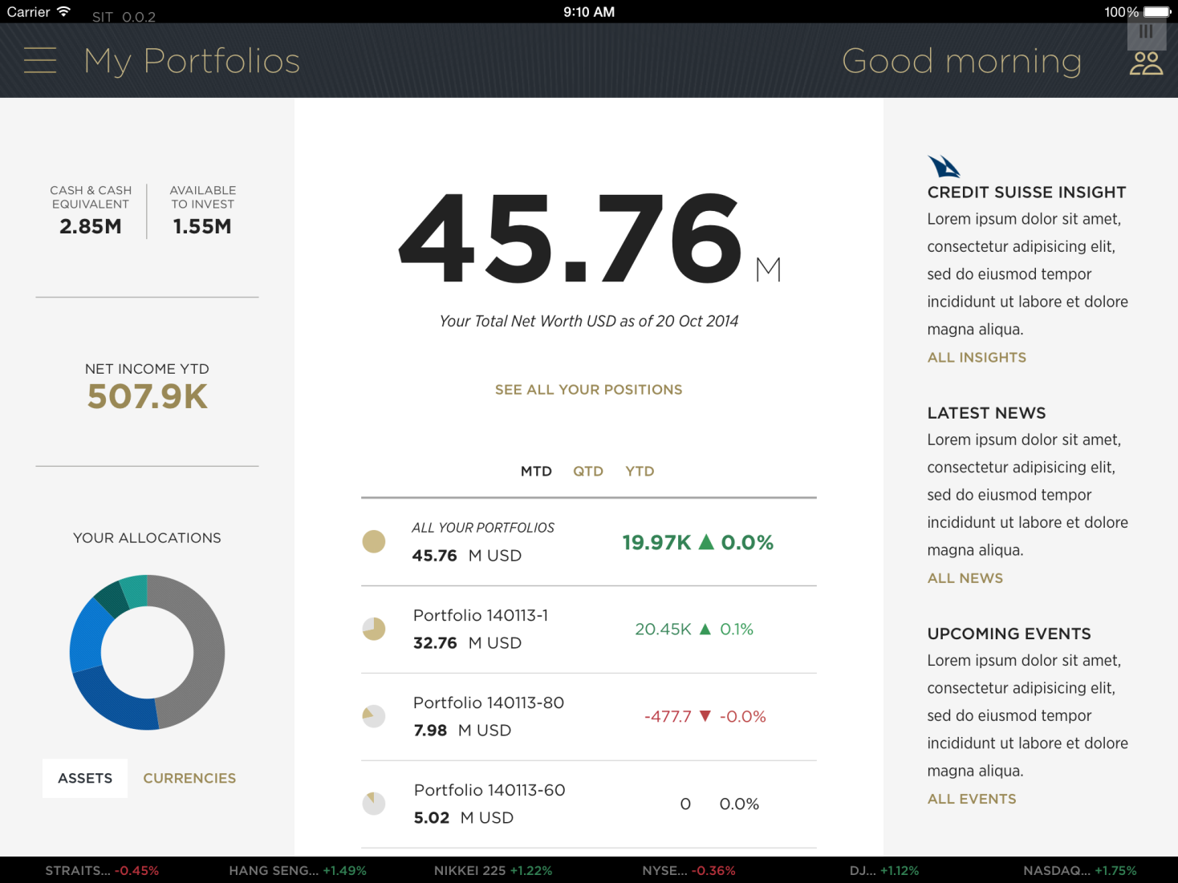

This page verifies:

| **Systems / JAP Components** | **Verifications** |
| --- | --- |
| SiteMinder | 2FA flow is OK. Encryption of CIF, Portfolio is OK |
| BL1 – Security | ExternalUserEntitlement.json |
| BL1 – Buying Power | BuyingPower.json |
| BL1 – Alerts / Push Notifications | AppleDevice.json |
| DPX (CRM / Workflow) | ExternalUser.json |
| DPX (Portfolio Data) | AssetAllocation.json, Performance.json, CifPortfolio.json, Liquidity.json, IncomeExpenditure.json,PositionInstrument.json |
| SIC (Market Data) | /lists/Six.json |
| BV (Reference Data) | contactMeTopics.json |
| Collaboration | getContactListForClient.json  Lync – MSFT Trusted App, HeartBeat Service |

# Portfolio – All Positions

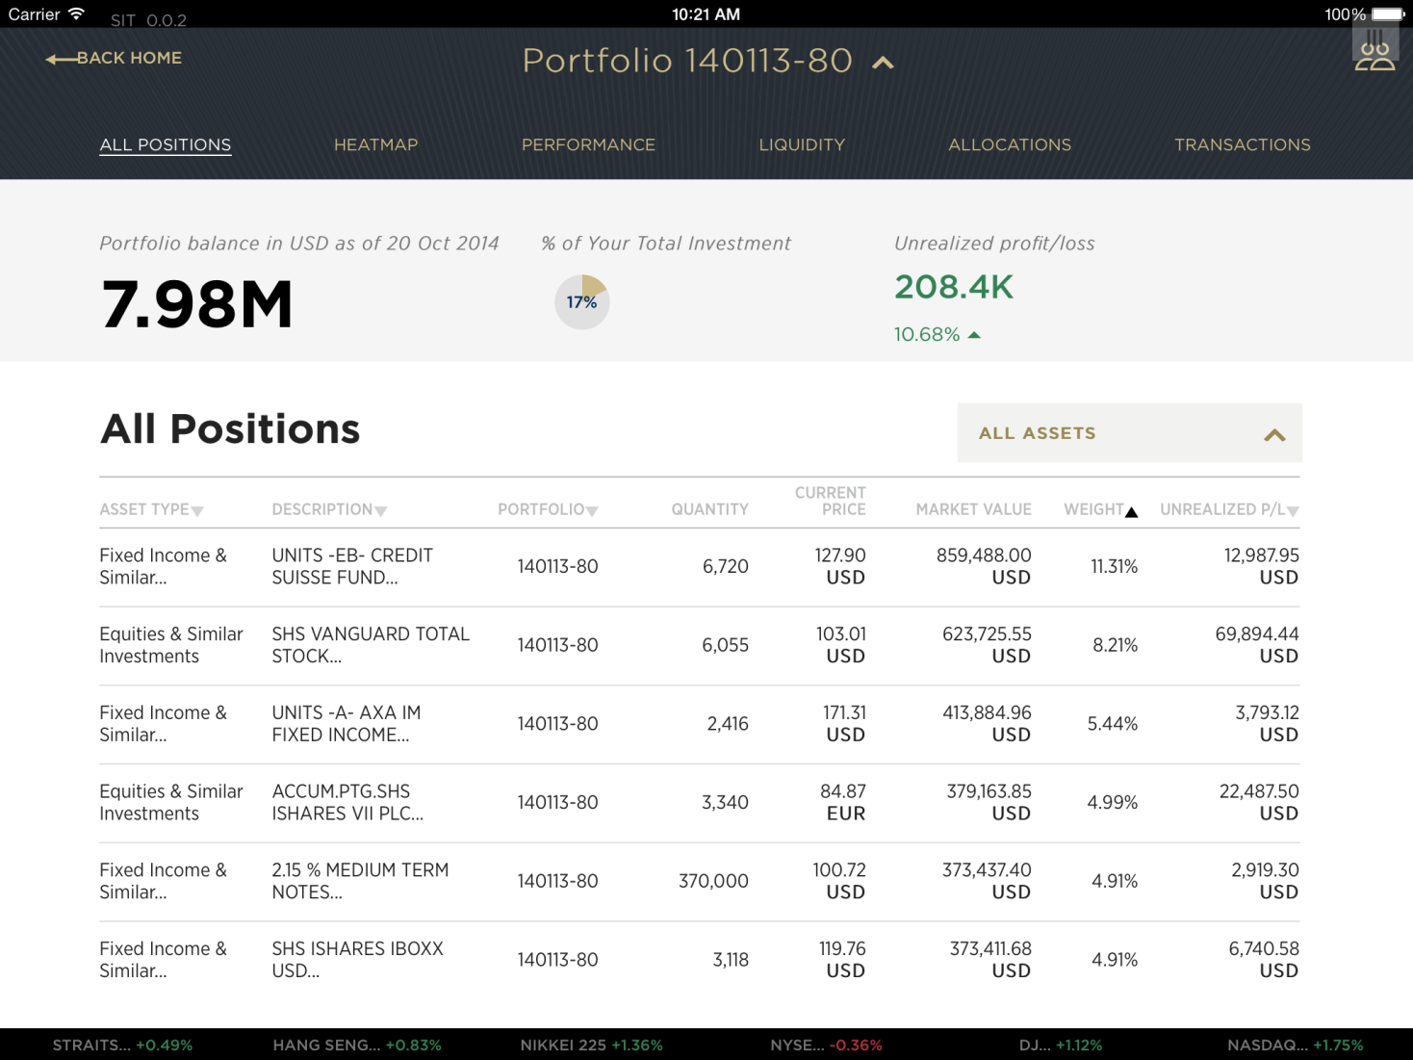

This page verifies:

|  |  |
| --- | --- |
| **Systems / JAP Components** | **Verifications** |
| DPX (Portfolio Data) | AssetAllocation.json, Position.json |
| BV (Reference Data) | positionCategories.json |
|  |  |
|  |  |
|  |  |

# Portfolio – Liquidity

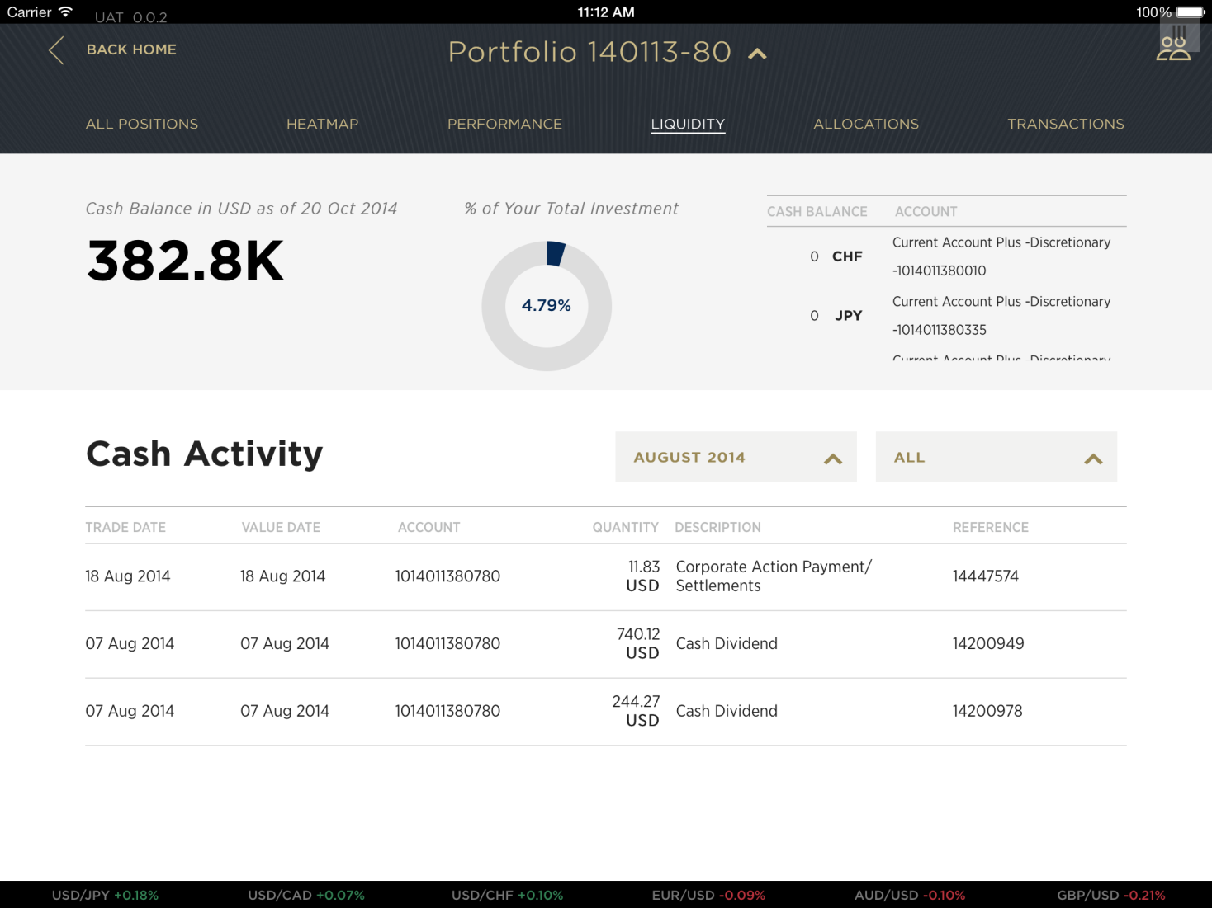

This page verifies:

|  |  |
| --- | --- |
| **Systems / JAP Components** | **Verifications** |
| DPX (Portfolio Data) | Account.json, AccountActivity.json |
|  |  |
|  |  |
|  |  |
|  |  |

# Portfolio - Performance

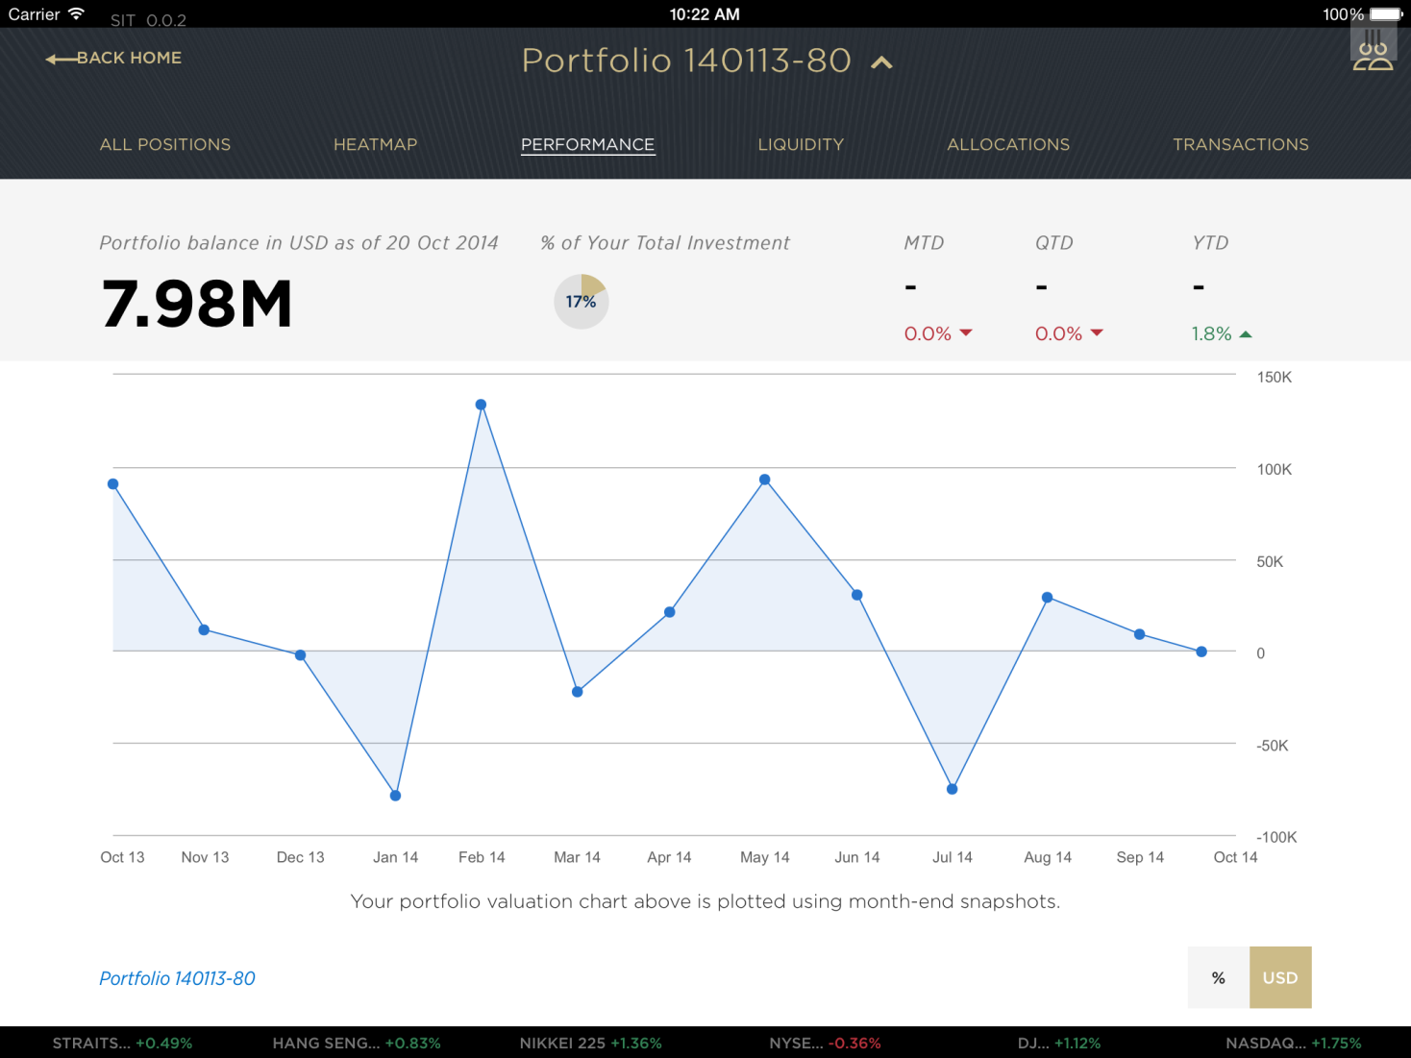

This page verifies:

|  |  |
| --- | --- |
| **Systems / JAP Components** | **Verifications** |
| DPX (Portfolio Data) | PortfolioPerformance.json,  Cached?: Performance.json, AssetAllocation.json |
|  |  |
|  |  |
|  |  |

# Portfolio - Transactions

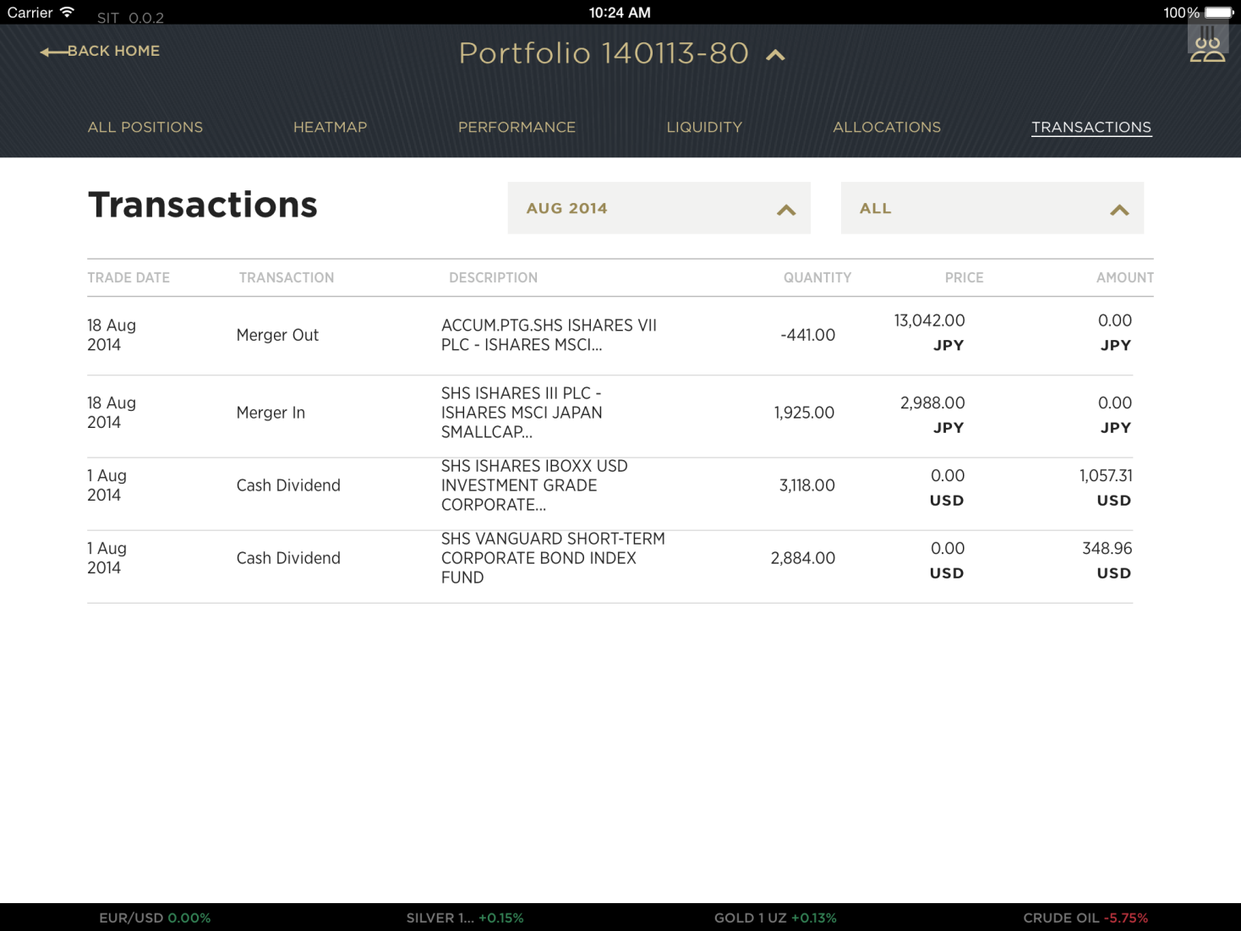

This page verifies:

|  |  |
| --- | --- |
| **Systems / JAP Components** | **Verifications** |
| DPX (Portfolio Data) | TransactionHistory.json |
|  |  |
|  |  |
|  |  |
|  |  |

# Portfolio – Income & Expenditure

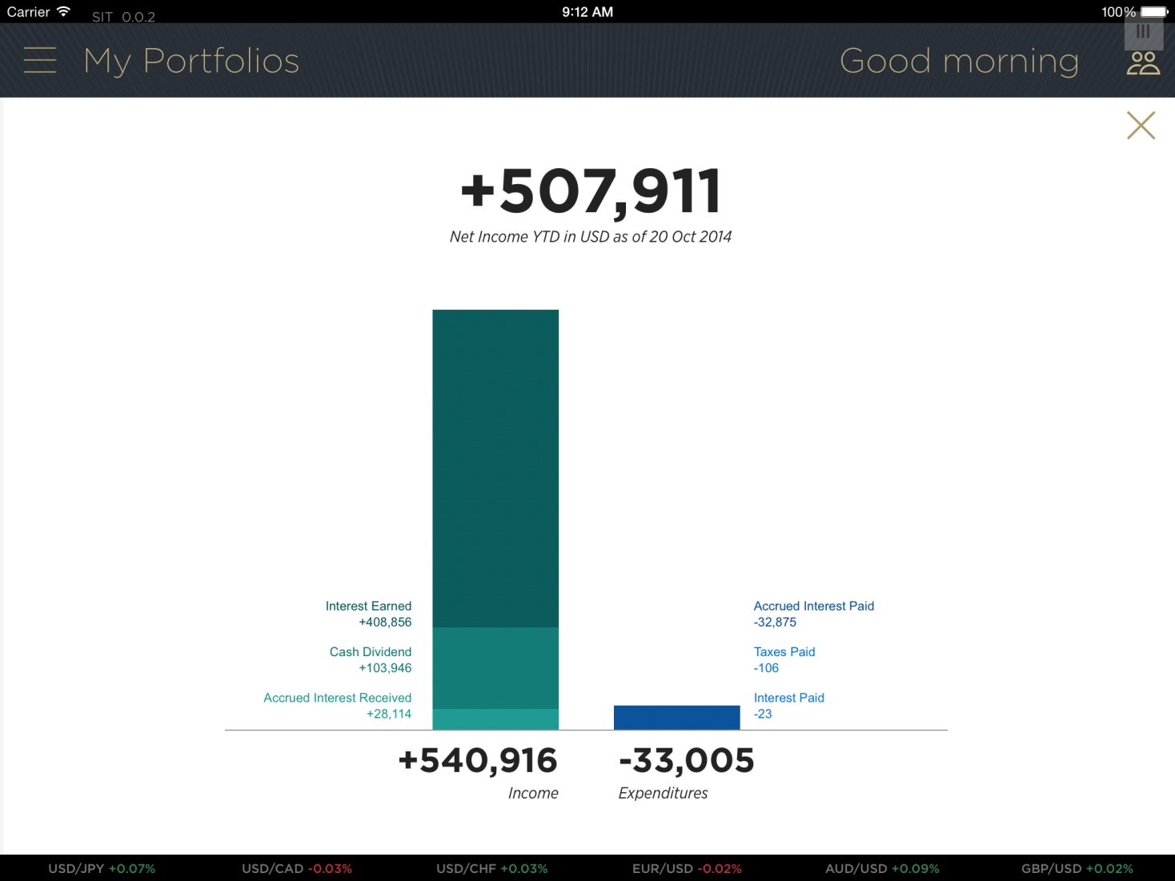

This page verifies:

|  |  |
| --- | --- |
| **Systems / JAP Components** | **Verifications** |
| DPX (Portfolio Data) | IncomeExpenditure.json |
|  |  |
|  |  |
|  |  |
|  |  |

# Portfolio – Asset Allocation

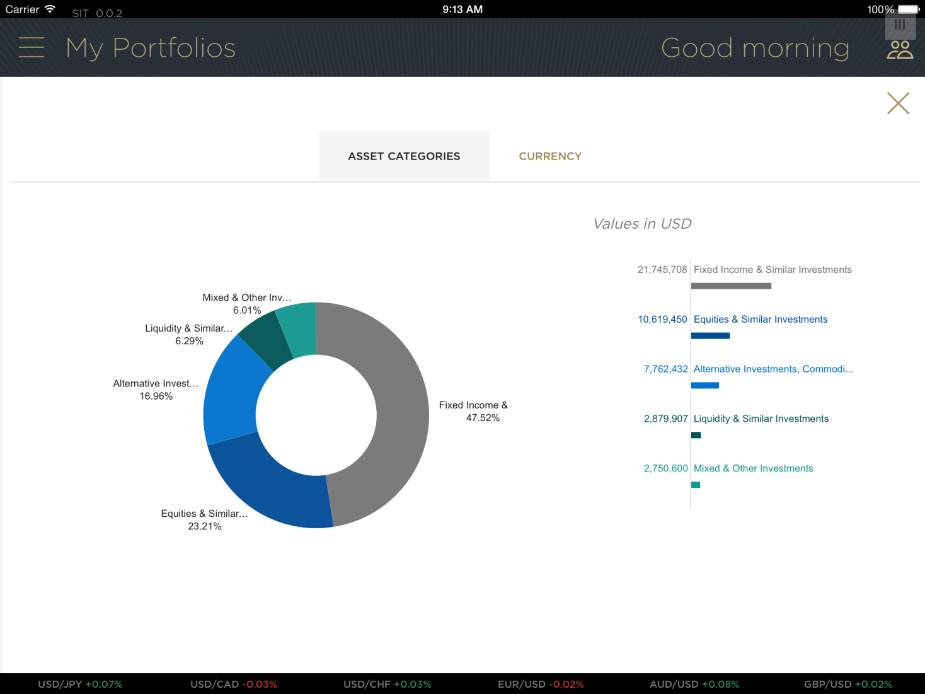

This page verifies:

|  |  |
| --- | --- |
| **Systems / JAP Components** | **Verifications** |
| DPX (Portfolio Data) | AssetAllocation.json |
|  |  |
|  |  |
|  |  |
|  |  |

# Portfolio – Currency Allocation

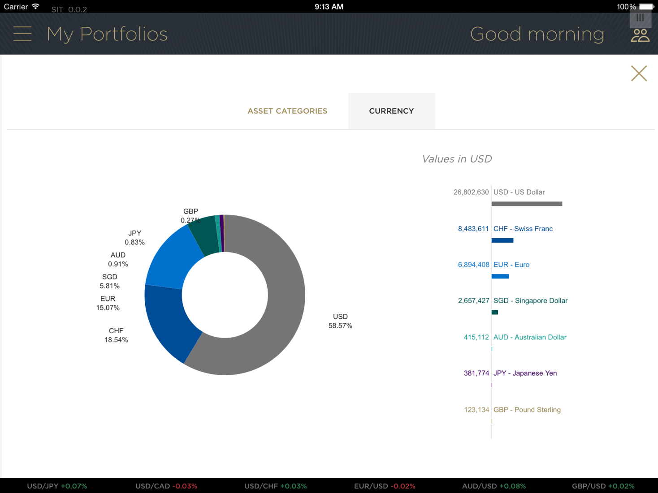

This page verifies:

|  |  |
| --- | --- |
| **Systems / JAP Components** | **Verifications** |
| DPX (Portfolio Data) | AssetAllocation.json |
|  |  |
|  |  |
|  |  |
|  |  |

# Portfolio – All Positions (All Asset Class)

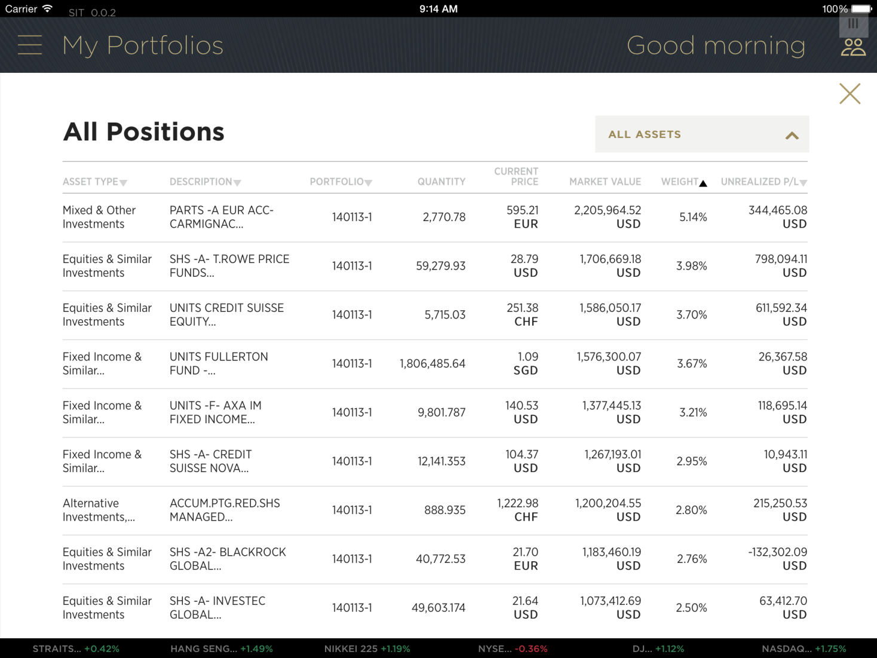

This page verifies:

|  |  |
| --- | --- |
| **Systems / JAP Components** | **Verifications** |
| DPX (Portfolio Data) | Position.json |
| BV (Reference Data) | positionCategories.json |
|  |  |
|  |  |
|  |  |

# Portfolio – All Positions (Filtered by Asset Class)

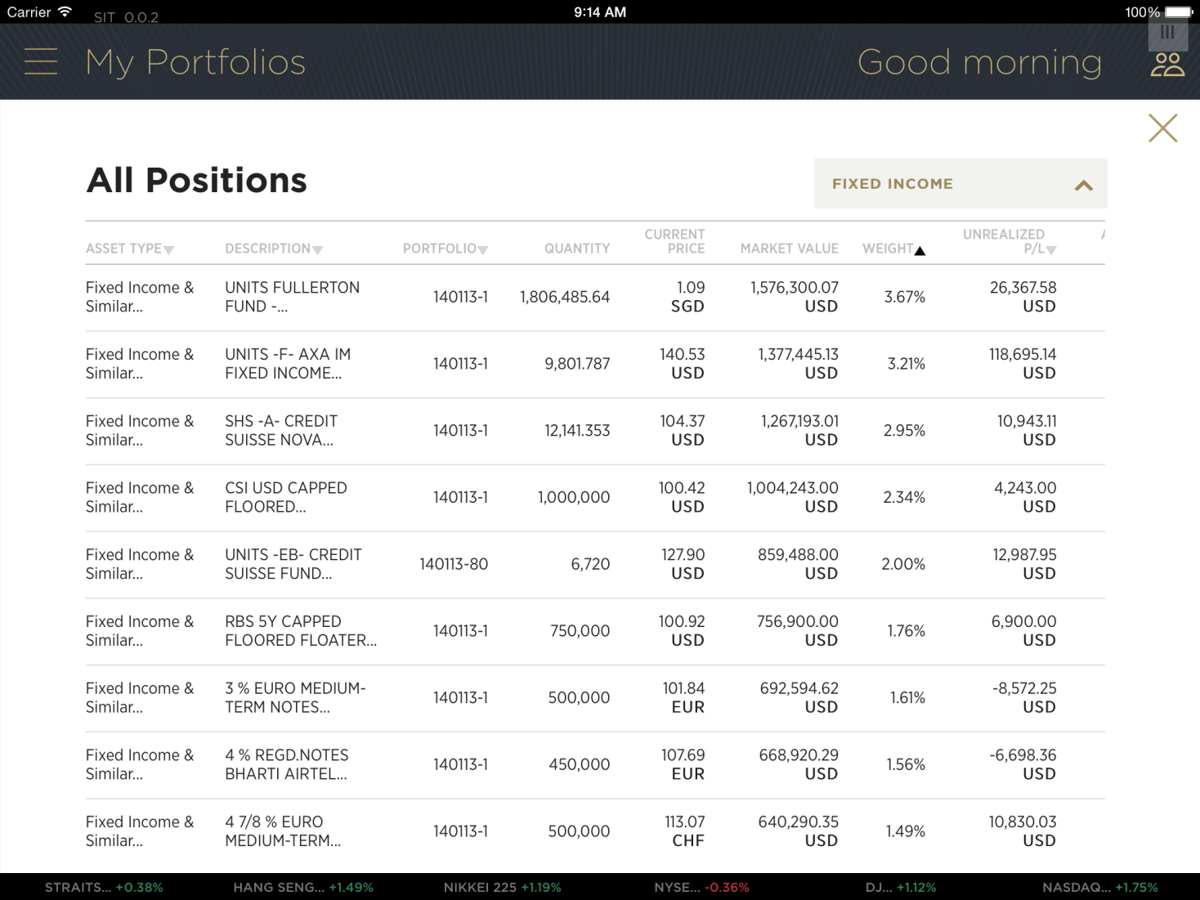

This page verifies:

|  |  |
| --- | --- |
| **Systems / JAP Components** | **Verifications** |
| DPX (Portfolio Data) | Position.json |
| BV (Reference Data) | positionCategories.json |
|  |  |
|  |  |
|  |  |

# Markets – Currencies

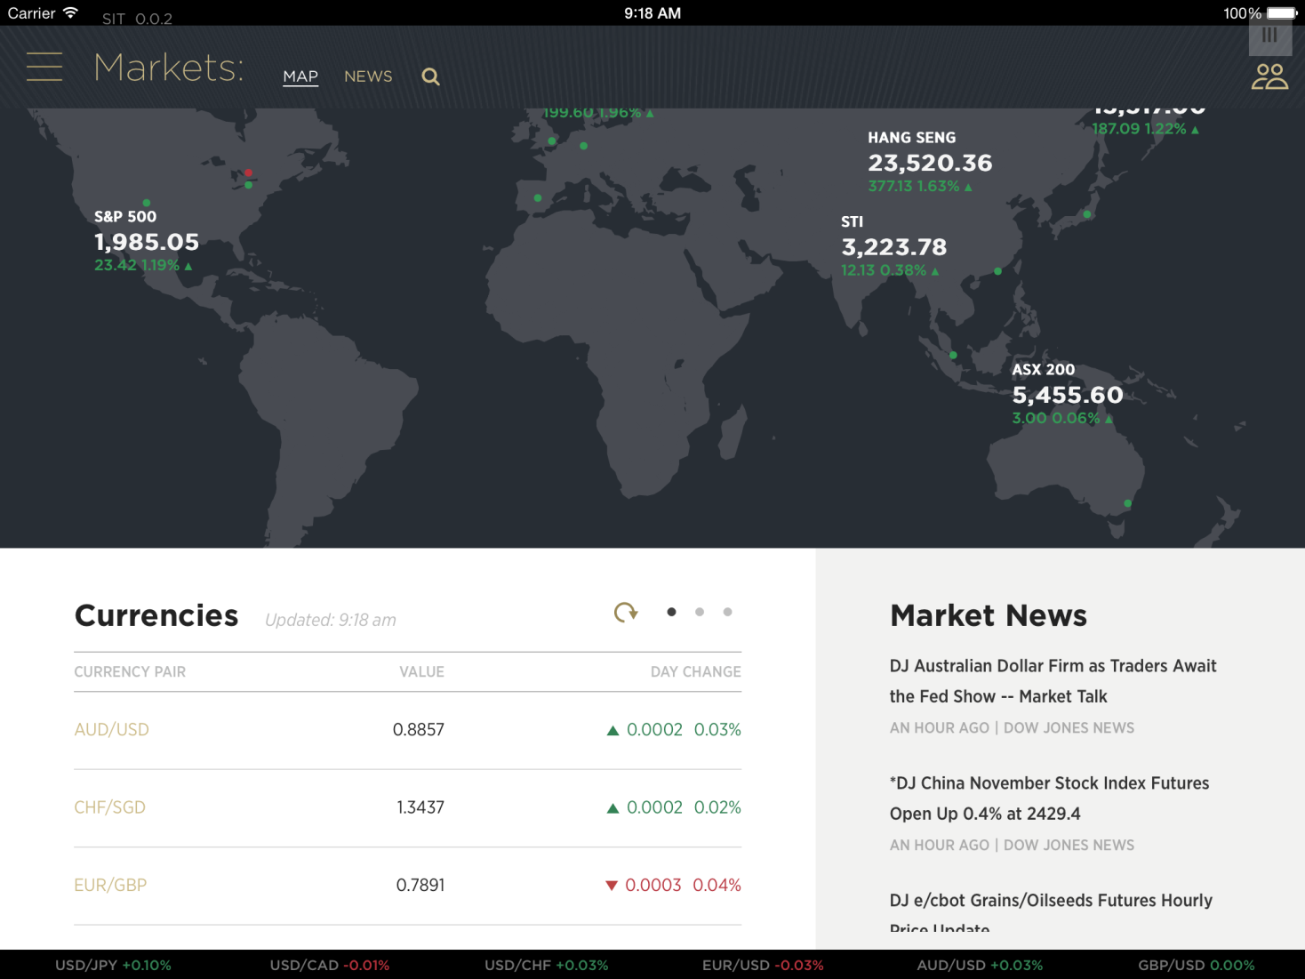

This page verifies:

|  |  |
| --- | --- |
| **Systems / JAP Components** | **Verifications** |
| SIC (Market Data) | /news/Six.json |
| SIC (Market Data) | /lists/Six.json |
| BV (Reference Data) | mapPoints.json |
| BV (Reference Data) | newsProvider.json |
|  |  |

# Markets – Bonds

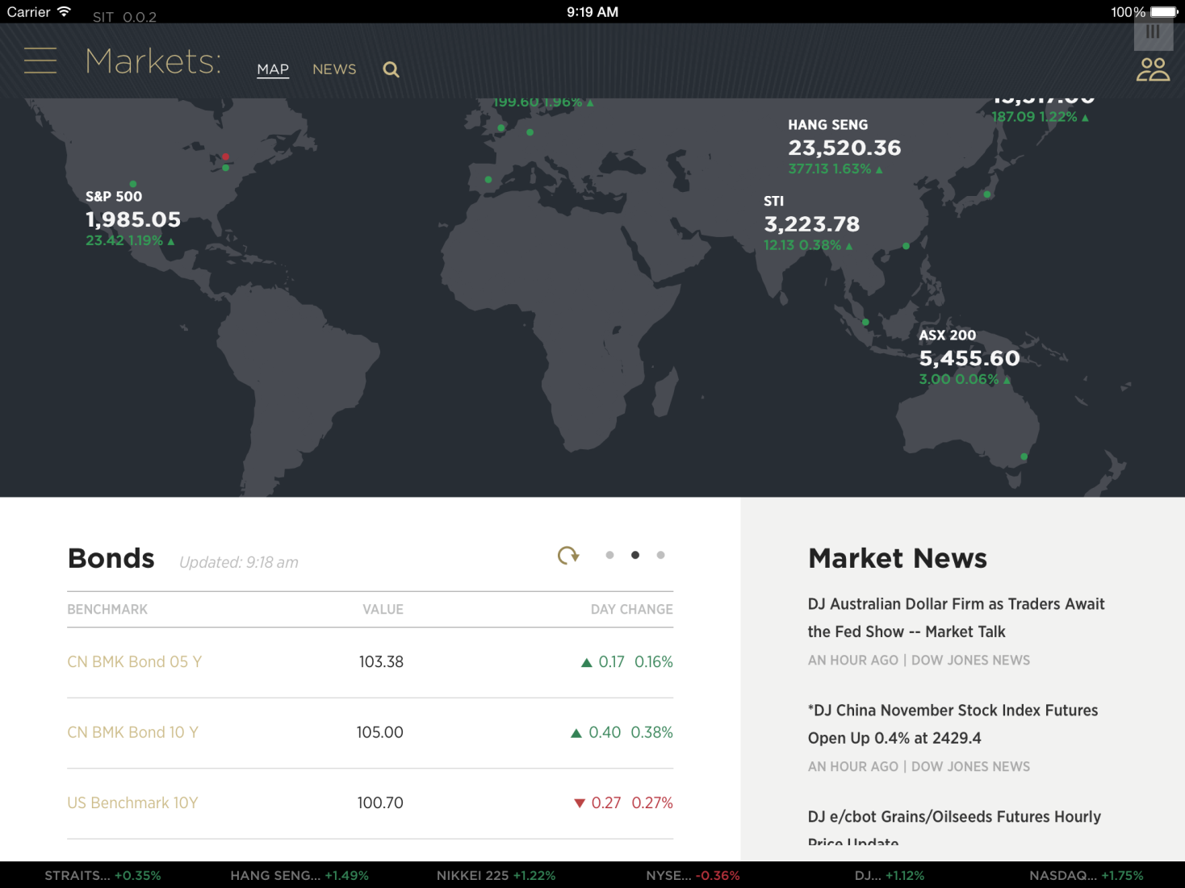

This page verifies:

|  |  |
| --- | --- |
| **Systems / JAP Components** | **Verifications** |
| SIC (Market Data) | /news/Six.json |
| BV (Reference Data) | newsProvider.json |
|  |  |
|  |  |
|  |  |

# Markets – Commodities

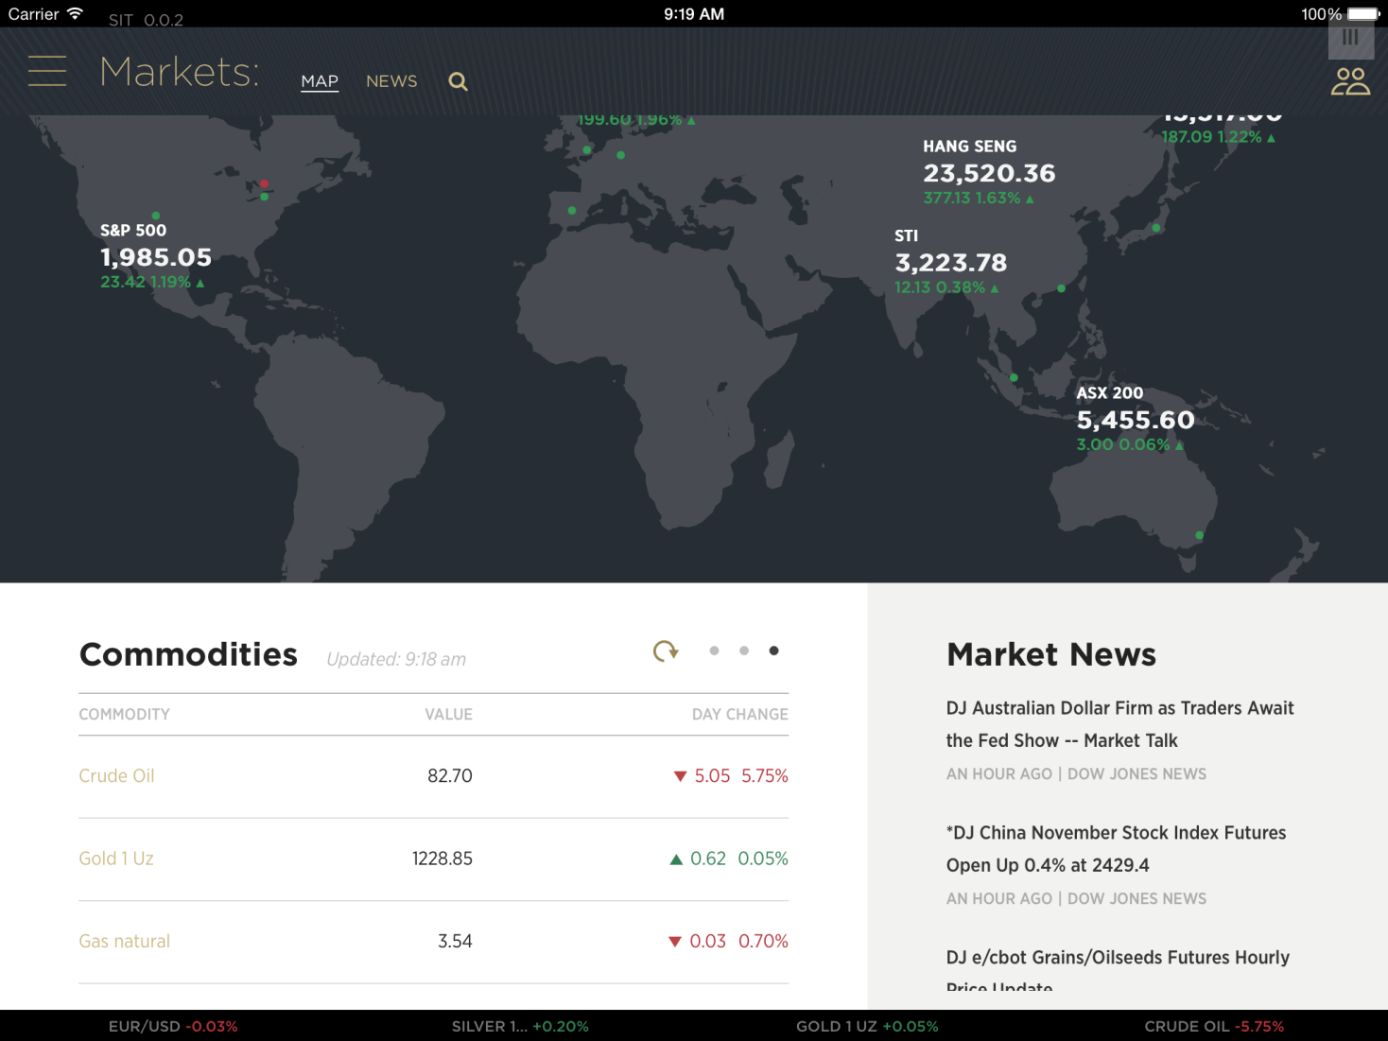

This page verifies:

|  |  |
| --- | --- |
| **Systems / JAP Components** | **Verifications** |
| SIC (Market Data) | /news/Six.json |
| BV (Reference Data) | newsProvider.json |
|  |  |
|  |  |
|  |  |

# Markets – News Summary

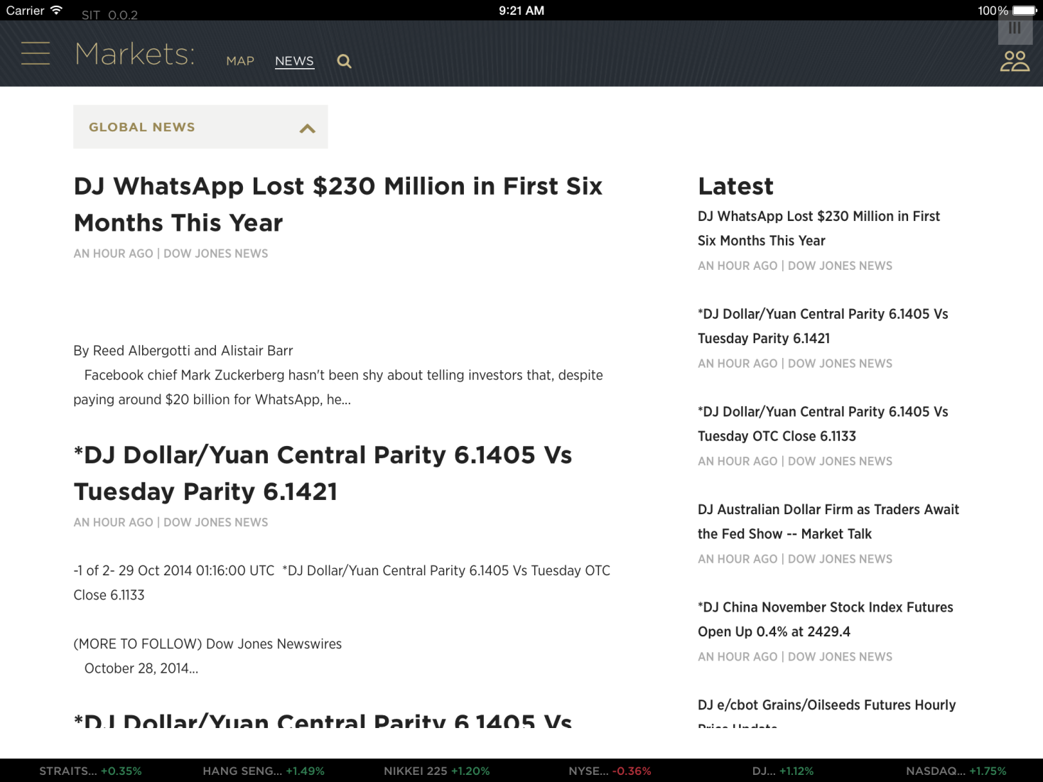

This page verifies:

|  |  |
| --- | --- |
| **Systems / JAP Components** | **Verifications** |
| SIC (Market Data) | /news/Six.json |
| BV (Reference Data) | newsProvider.json |
|  |  |
|  |  |
|  |  |

# Markets – News Detail



This page verifies:

|  |  |
| --- | --- |
| **Systems / JAP Components** | **Verifications** |
| SIC (Market Data) | /news/Six.json |
|  |  |
|  |  |
|  |  |
|  |  |

# Watchlist – List View

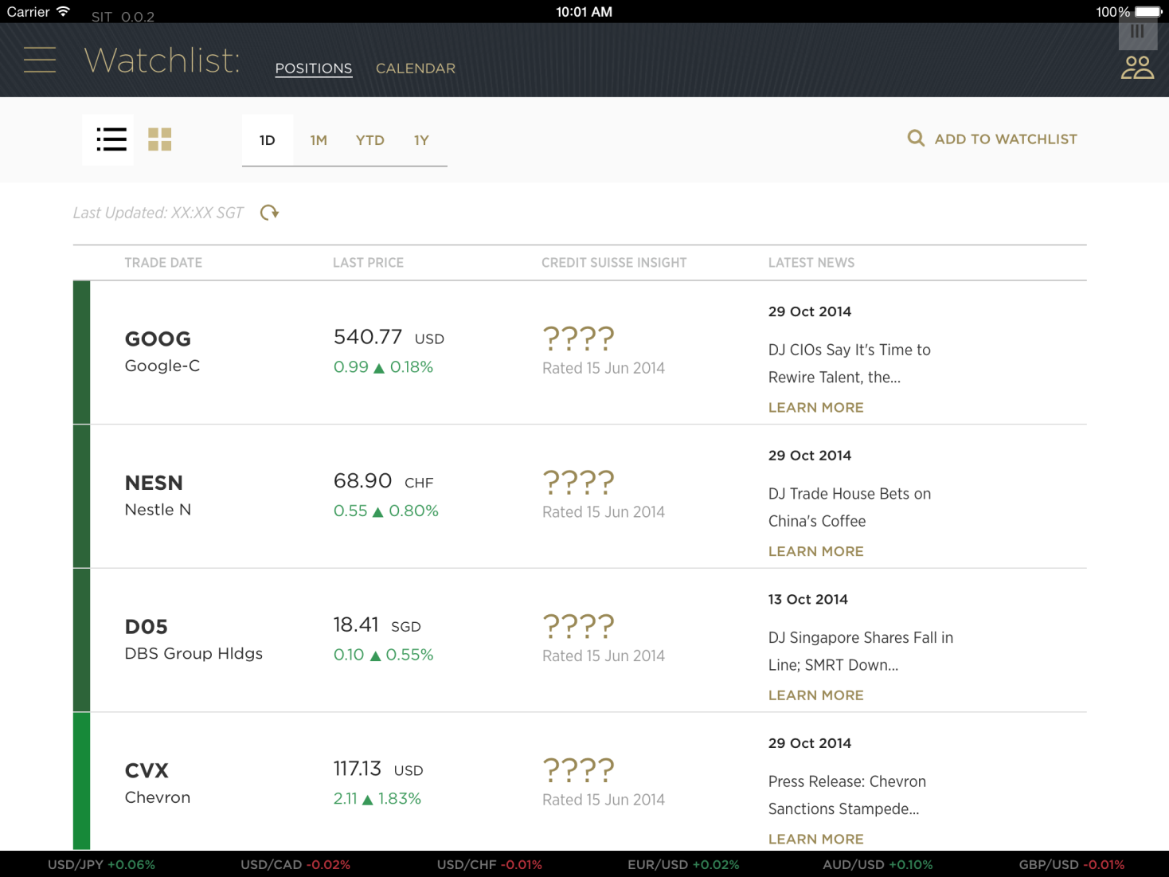

This page verifies:

|  |  |
| --- | --- |
| **Systems / JAP Components** | **Verifications** |
| SIC (Market Data) | /watchlists/Six.json |
|  |  |
|  |  |
|  |  |
|  |  |

# Watchlist – Grid View

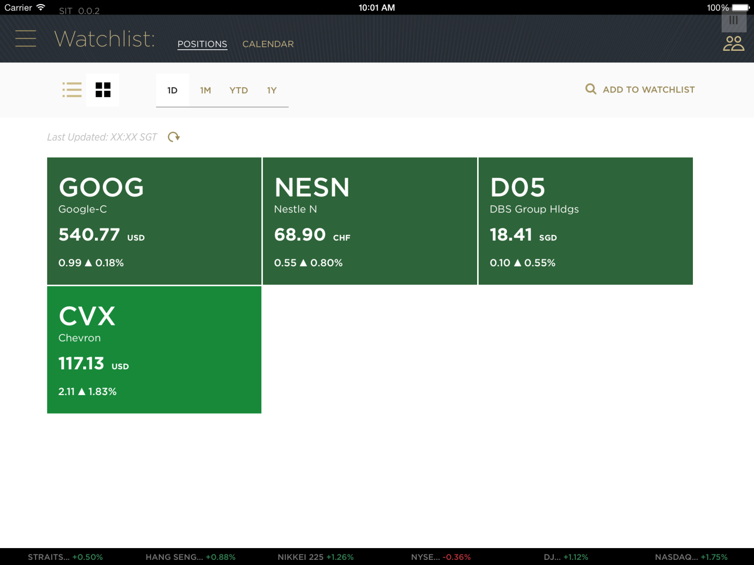

This page verifies:

|  |  |
| --- | --- |
| **Systems / JAP Components** | **Verifications** |
| SIC (Market Data) | /watchlists/Six.json |
|  |  |
|  |  |
|  |  |
|  |  |

# Search Instrument

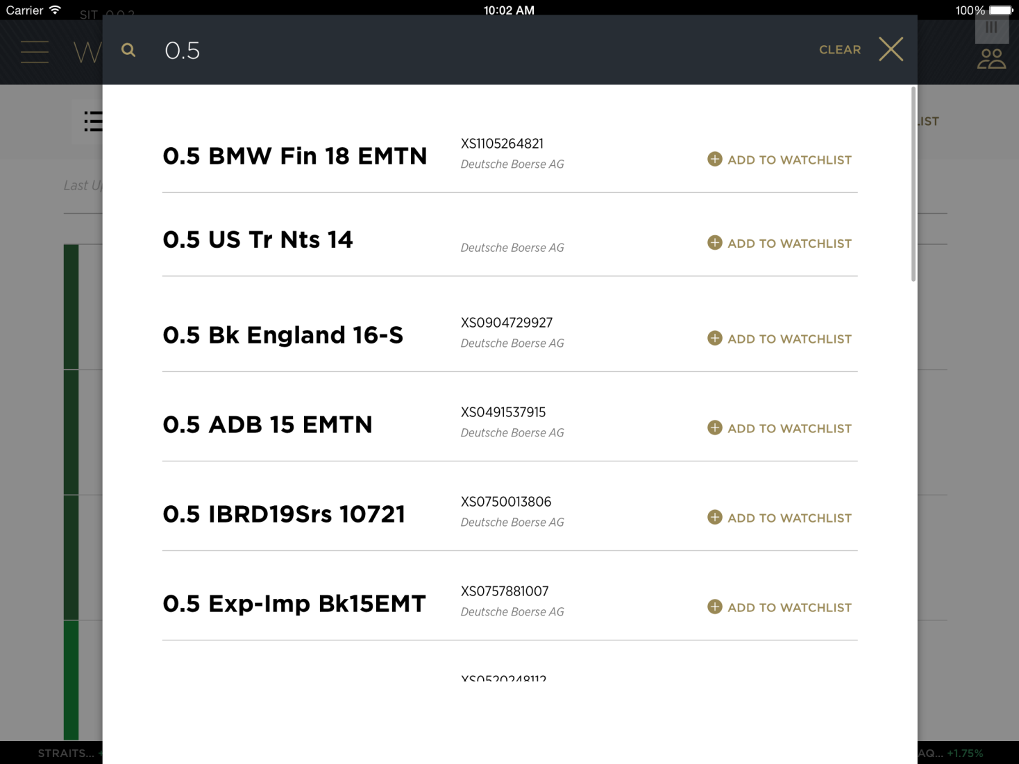

This page verifies:

|  |  |
| --- | --- |
| **Systems / JAP Components** | **Verifications** |
| SIC (Maket Data) | /quotes/Six.json/_search |
|  |  |
|  |  |
|  |  |
|  |  |

# Ideas – Home

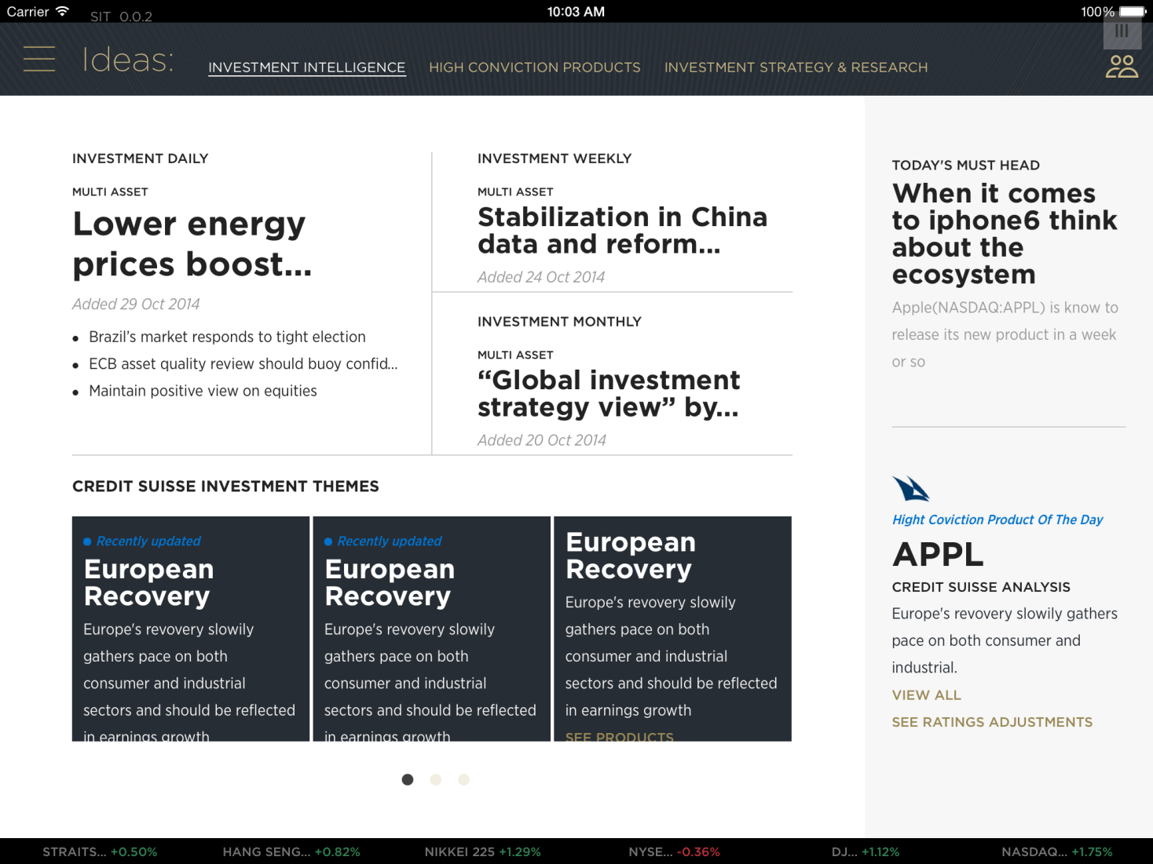

This page verifies:

|  |  |
| --- | --- |
| **Systems / JAP Components** | **Verifications** |
| BV (Reference Data) | getInvestmentThemes.json |
| BV (Reference Data) | getResearchCategories.json |
| BVMC | Right-hand corner (curated content) |
| ISR | ResearchDataByCategory (DPB0v1/AppLayerSearch/Search) |
| SIX | InvestmentThemes.json |
| SIX | /buffet/Six.json |

# Ideas – Products By

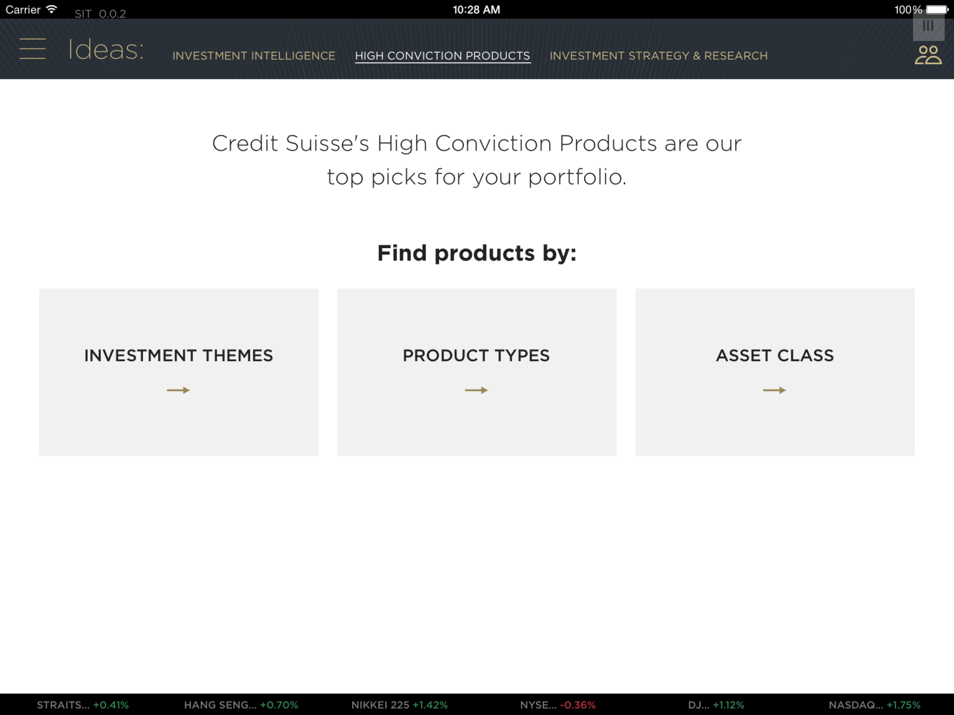

This page verifies:

|  |  |
| --- | --- |
| **Systems / JAP Components** | **Verifications** |
| BV (Reference Data) | identifyProductInstruments.json |
|  |  |
|  |  |
|  |  |
|  |  |

# Ideas – Products (Investment Themes)

<add the screen for Investment themes>

This page verifies:

|  |  |
| --- | --- |
| **Systems / JAP Components** | **Verifications** |
| SIX (InvestmentThemes) | InvestmentThemes.json |
| SIX (Product Buffet) | ProductBuffet (/buffet/Six.json/_filter) |
|  |  |
|  |  |
|  |  |

# Ideas – Product Types

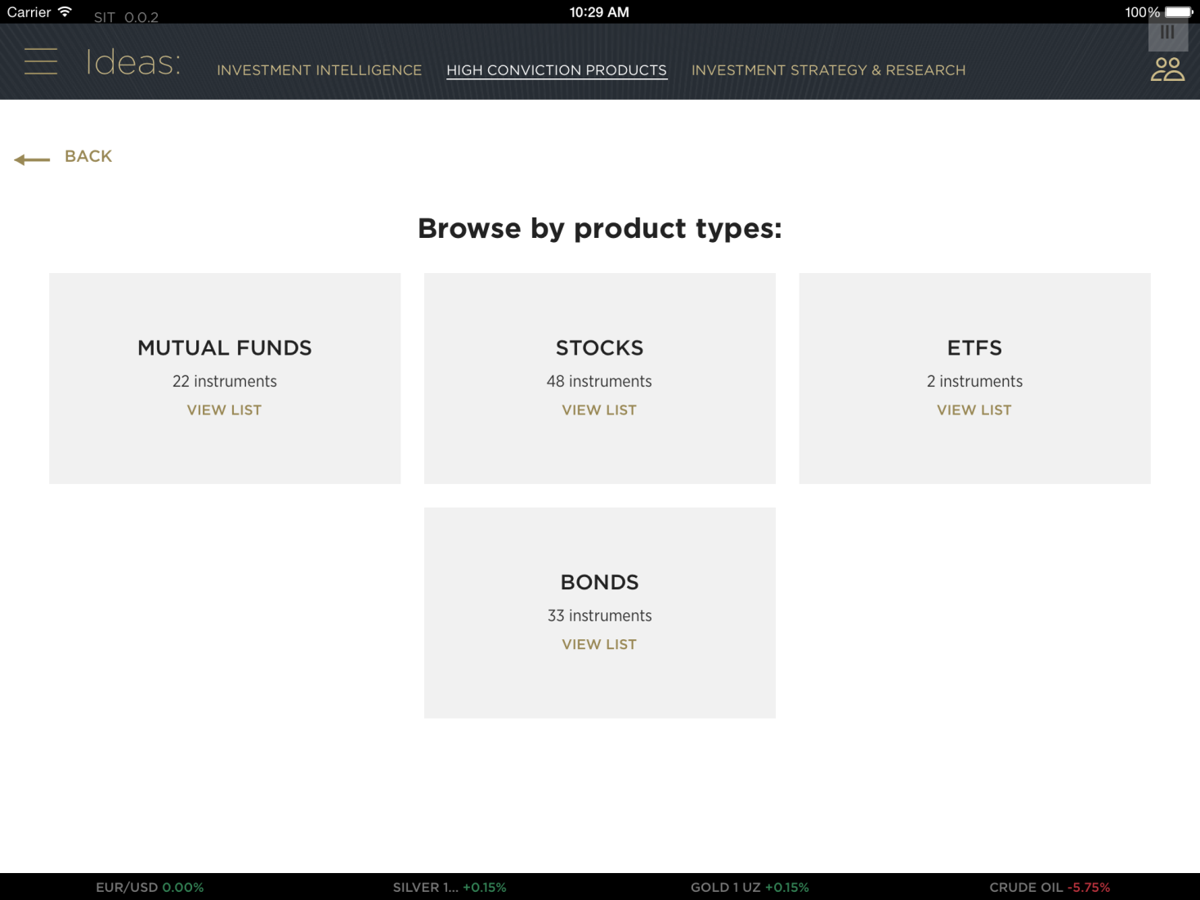

This page verifies:

|  |  |
| --- | --- |
| **Systems / JAP Components** | **Verifications** |
| SIX (& Product Buffet) | ProductBuffet (/buffet/Six.json/_filter) (for the instrument counts) |
|  |  |
|  |  |
|  |  |
|  |  |

# Ideas – Recommended Ideas

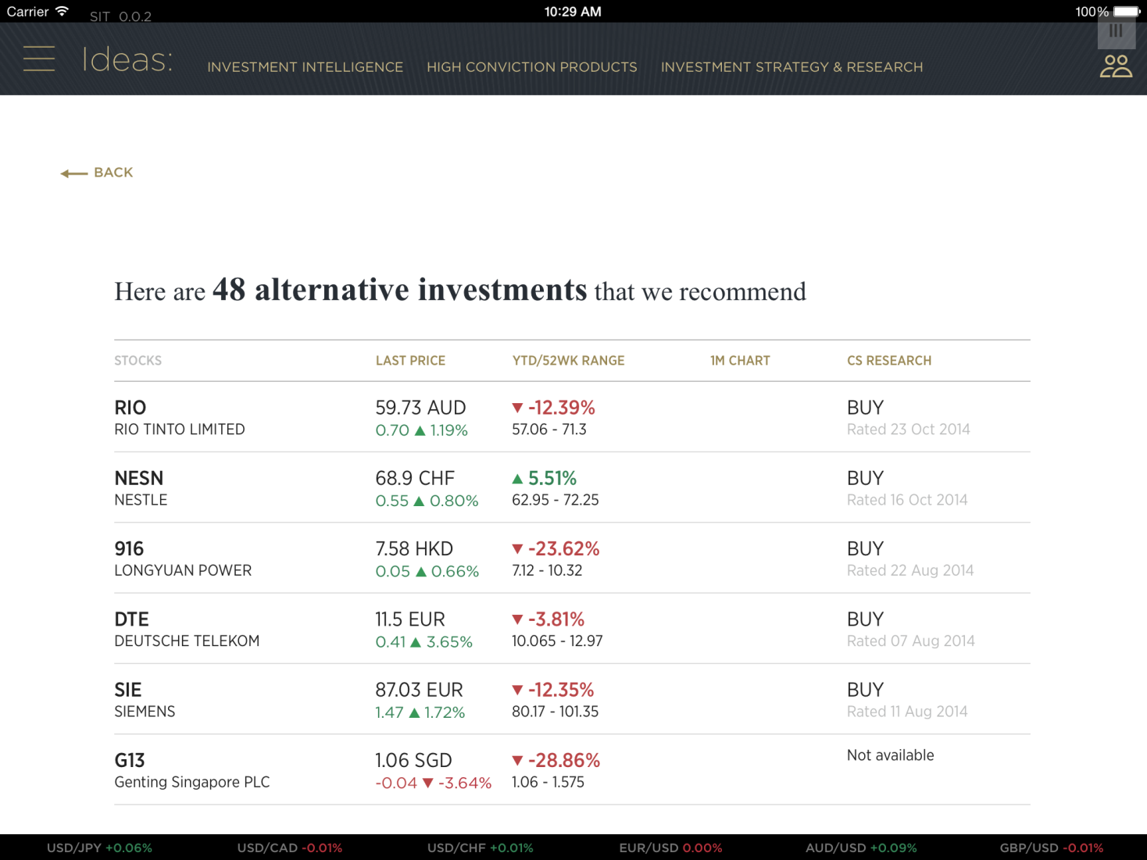

This page verifies:

|  |  |
| --- | --- |
| **Systems / JAP Components** | **Verifications** |
| SIX (& Product Buffet) | productBuffet.json |
|  |  |
|  |  |
|  |  |
|  |  |

# Ideas – Products

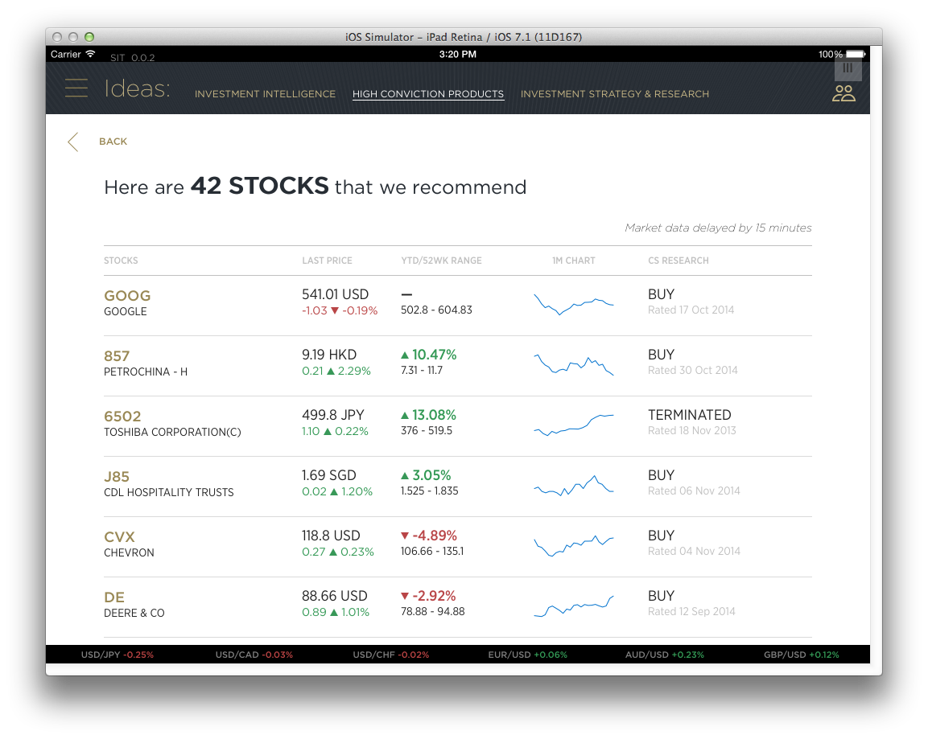

This page verifies:

|  |  |
| --- | --- |
| **Systems / JAP Components** | **Verifications** |
| SIX (& Product Buffet) | productBuffet.json |
| For the Sparklines in the page | /chartsdata/Six.json |
|  |  |
|  |  |
|  |  |

# Ideas – Instrument details

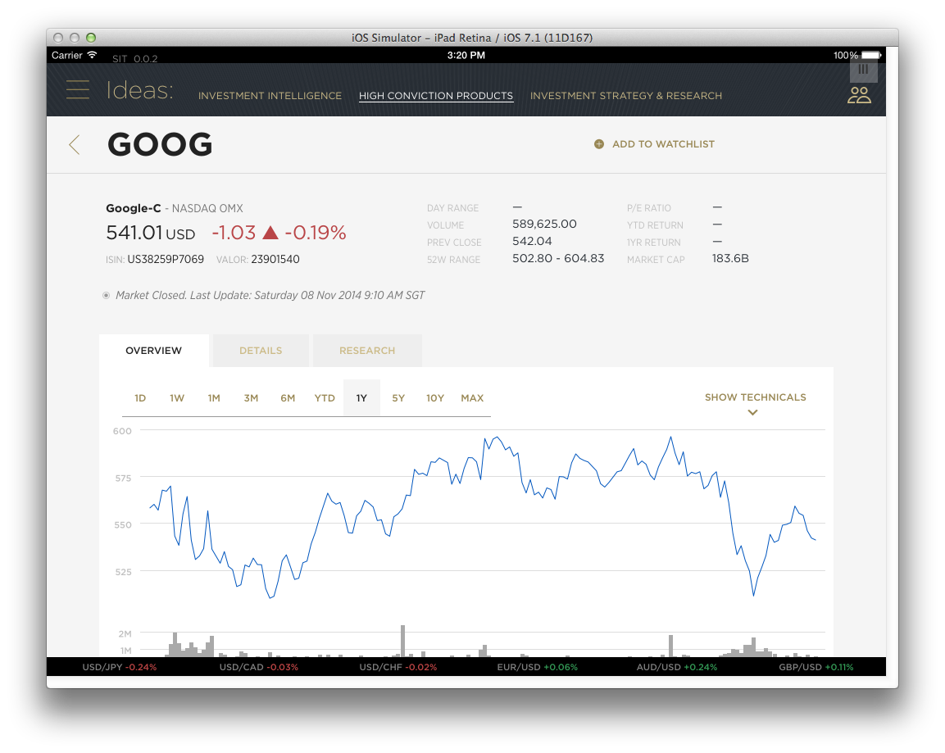

This page verifies:

|  |  |
| --- | --- |
| **Systems / JAP Components** | **Verifications** |
| SIX (quotes) | (SixInstrumentQuotes) /quotes/Six.json |
| SIX (charts) | (ChartSeries) /chartsdata/Six.json |
| SIX (news) | (NewsSix.json) /csnews/Six.json/_search |
| BVMC (3rd party analysis) | thirdPartyAnalysis.json |
|  |  |

# Ideas – By Strategy & Research

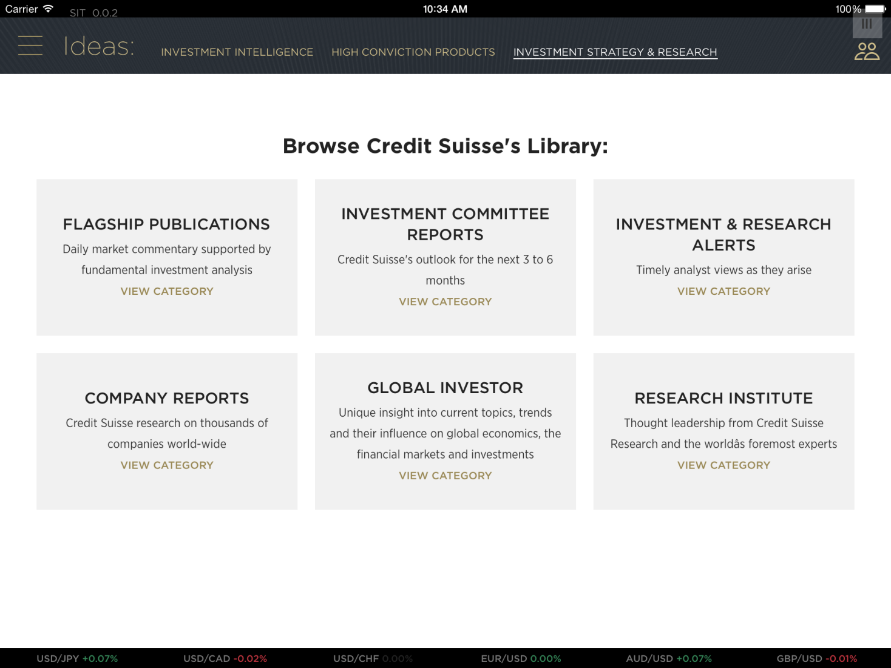

This page verifies:

|  |  |
| --- | --- |
| **Systems / JAP Components** | **Verifications** |
| BV (Reference Data) | getCategories.json |
|  |  |
|  |  |
|  |  |
|  |  |

# Filter Ideas

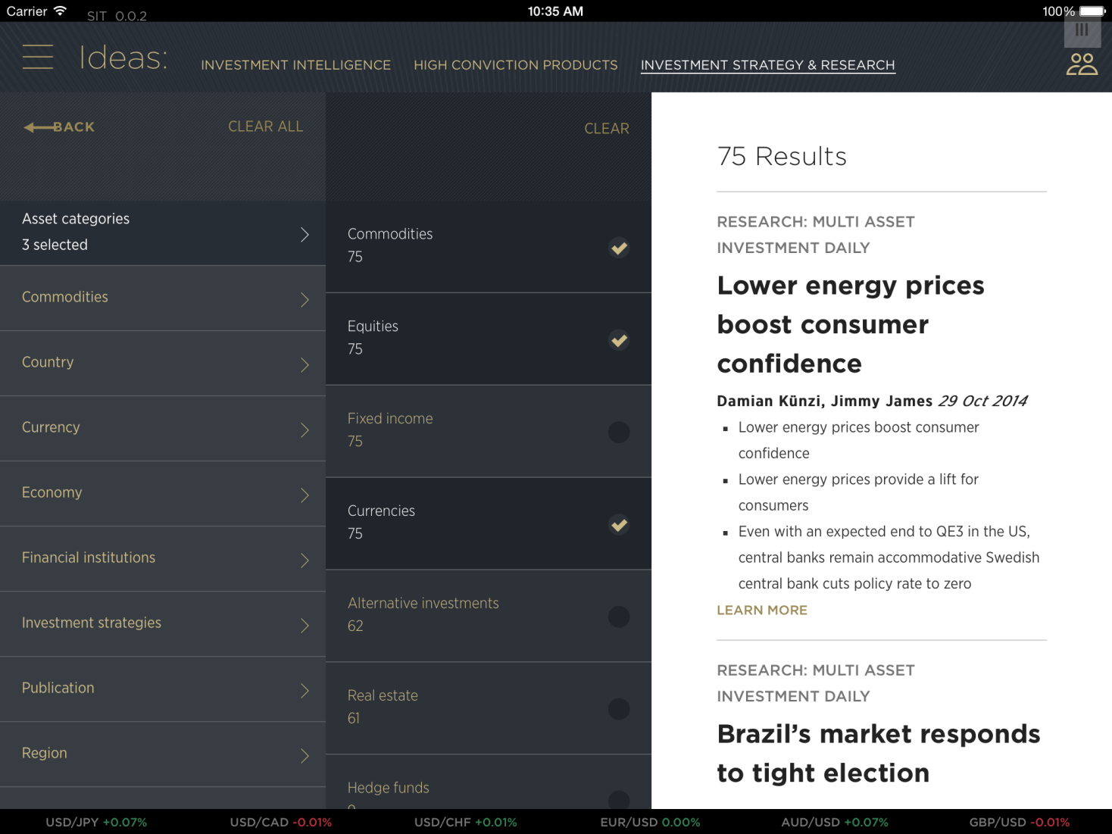

This page verifies:

|  |  |
| --- | --- |
| **Systems / JAP Components** | **Verifications** |
| ISR | ResearchDataByCategory (DPB0v1/AppLayerSearch/Search) |
|  |  |
|  |  |
|  |  |
|  |  |

# Ideas – PDF Report

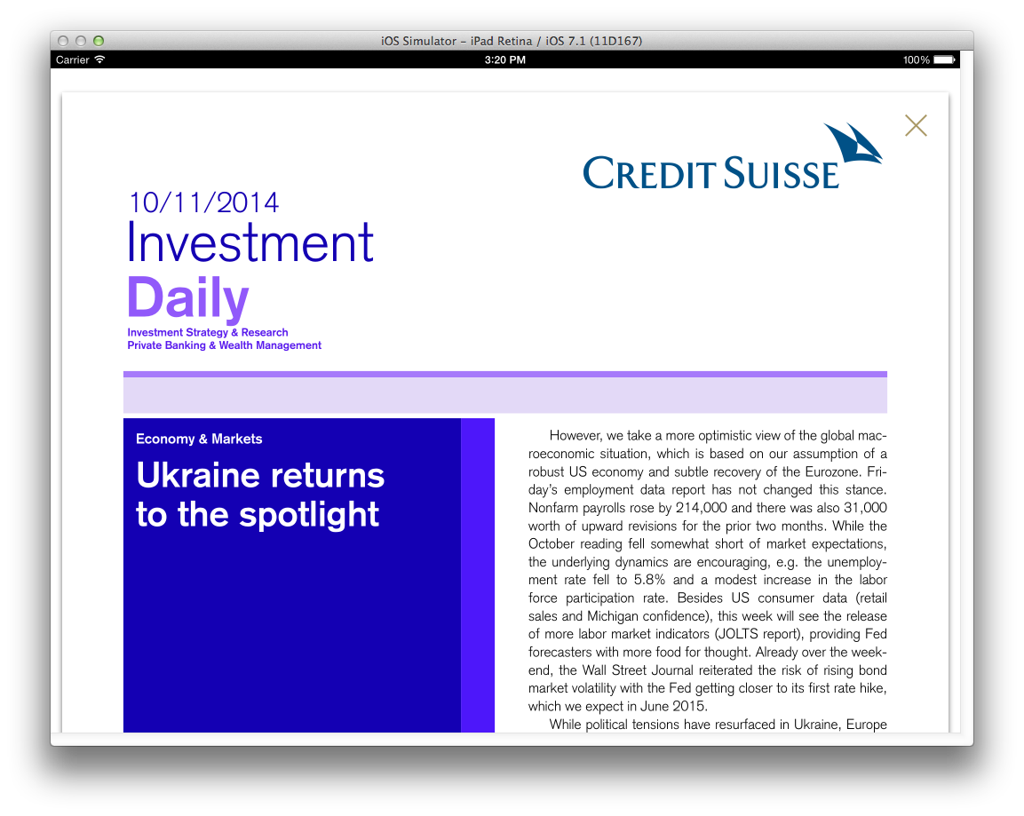

This page verifies:

|  |  |
| --- | --- |
| **Systems / JAP Components** | **Verifications** |
| ISR | ResearchDocument (Document/ResolveUri) |
|  |  |
|  |  |

# Trade – Landing Page, with Buying Power

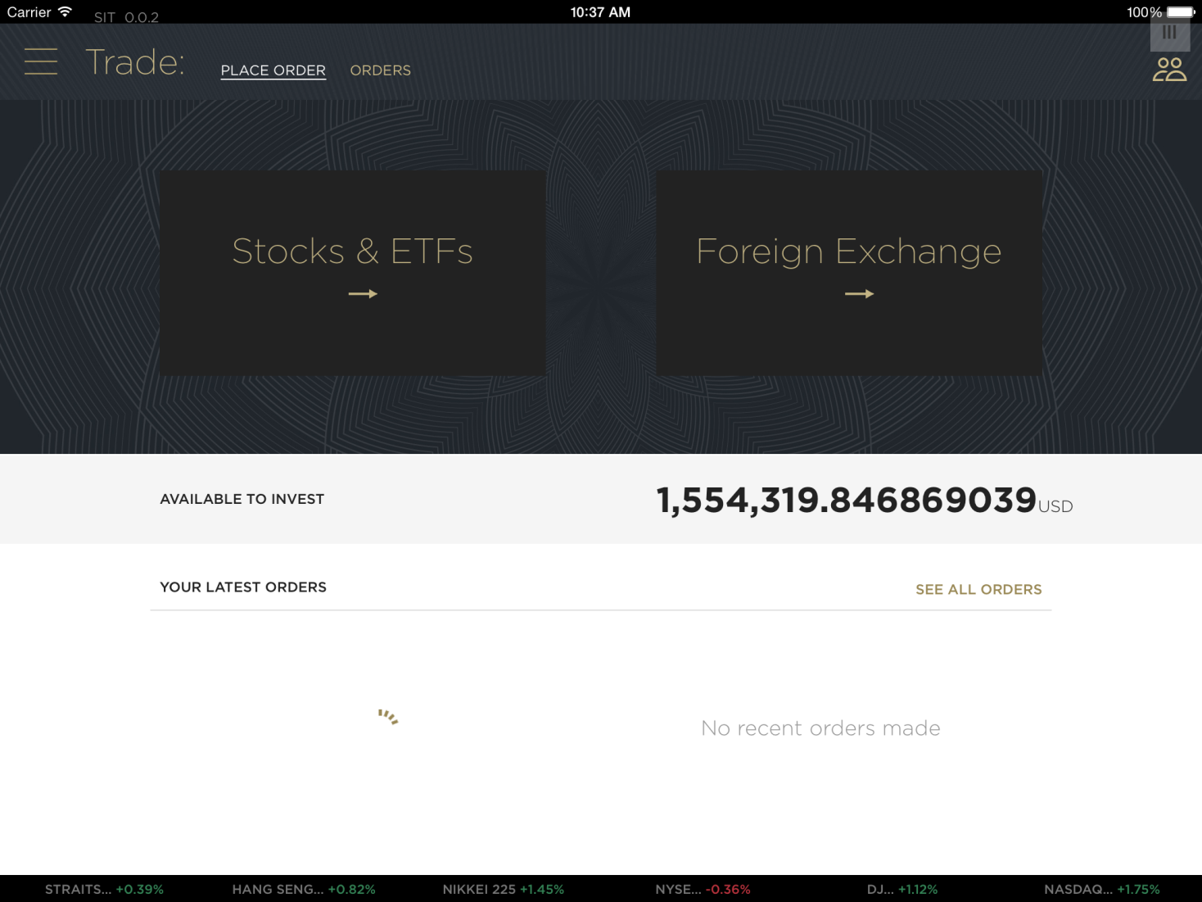

This page verifies:

|  |  |
| --- | --- |
| **Systems / JAP Components** | **Verifications** |
| BL1 (Buying Power) | BuyingPower.json |
| BL1 (Consolidated Blotter) | Orders.json |
| RUL (Fit For Trading) | FitForTrading.json |
|  |  |
|  |  |

# Trade – Equity, with Fit-for-Trade

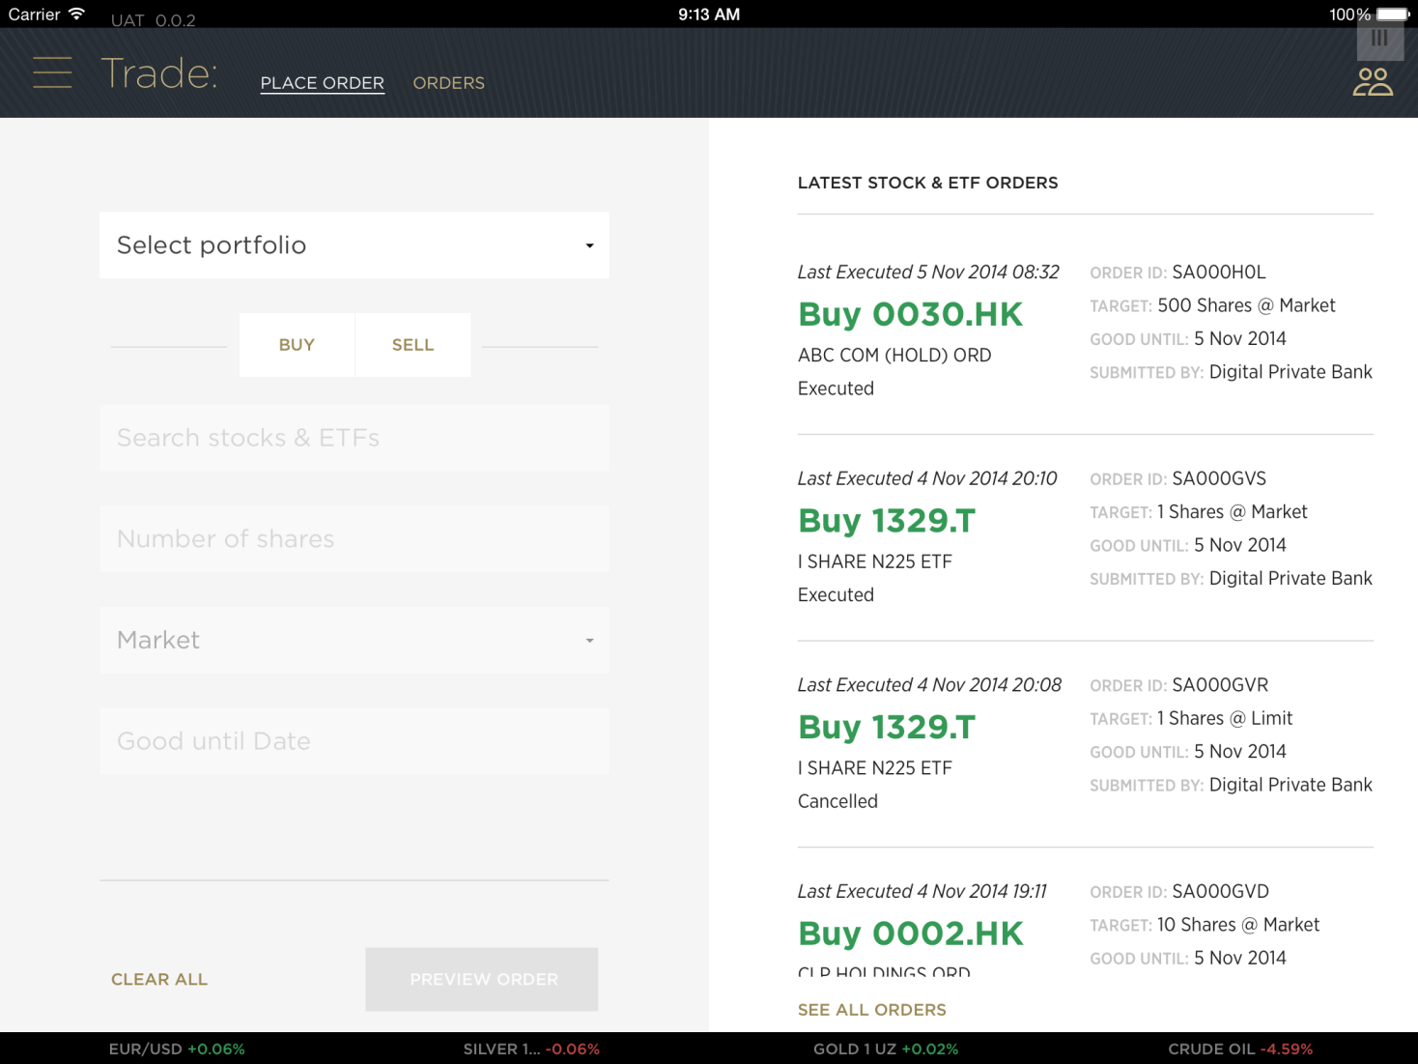

This page verifies:

|  |  |
| --- | --- |
| **Systems / JAP Components** | **Verifications** |
| RUL (Fit For Trading) | FitForTrading.json |
| BL1 (Consolidated Blotter) | Orders.json |
| SpiritAsia (ISIN-Value, ISIN-Details) | /instruments/Equity |
| SpiritAsia (Order Dates) | /order-dates |
|  |  |
|  |  |

# Trade – Equity Calendar

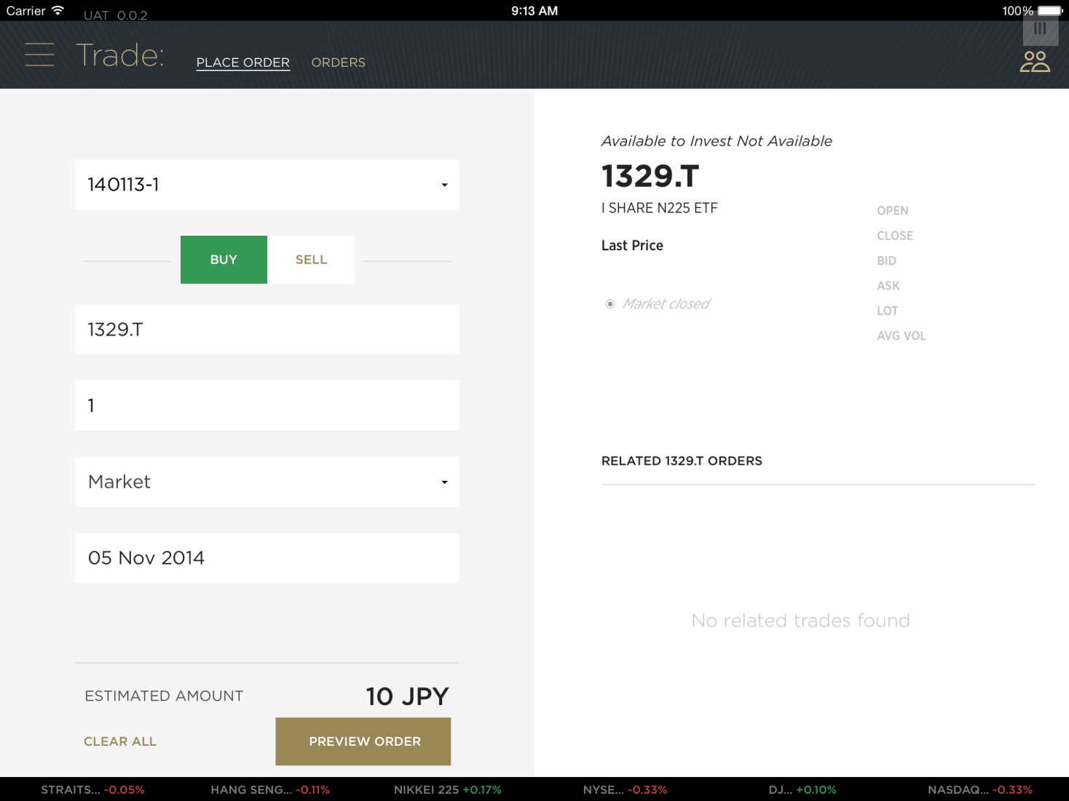

This page verifies:

|  |  |
| --- | --- |
| **Systems / JAP Components** | **Verifications** |
| BL1 (IntraDay) | PositionAvailability.json |
| BL1 (Buying Power) | BuyingPower.json |
| SpiritAsia (Validate) | /order/validate |
|  |  |
|  |  |

# Trade – FX, with Fit-for-Trade

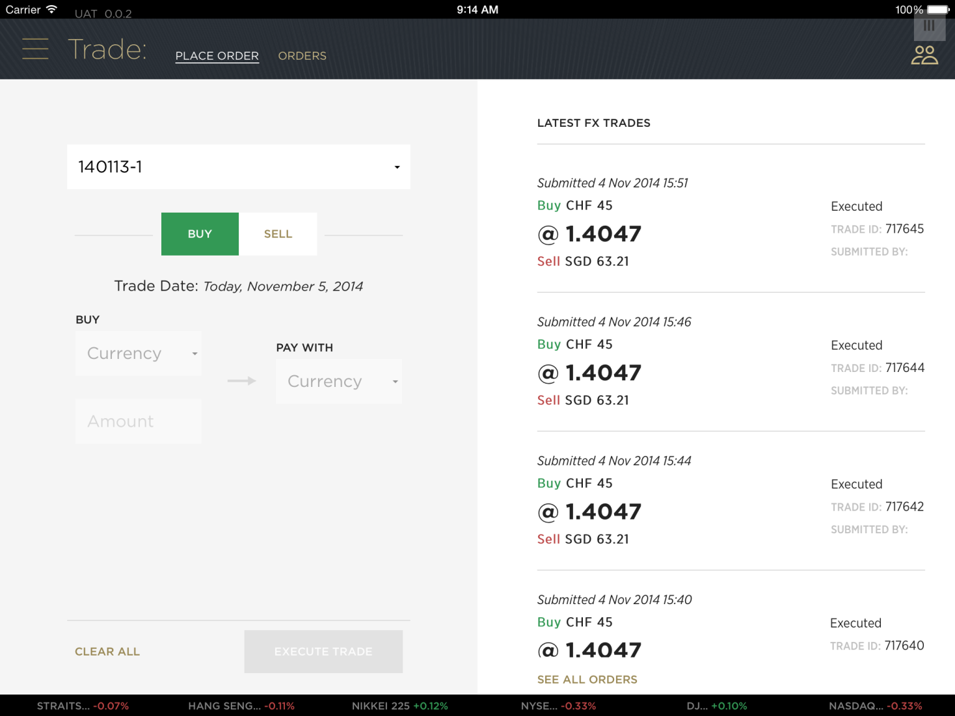

This page verifies:

|  |  |
| --- | --- |
| **Systems / JAP Components** | **Verifications** |
| MySolutions | FxService.svc/Currencies |
| BL1 (Consolidated Blotter) | Orders.json |
| RUL (Fit For Trading) | FitForTrading.json |
|  |  |
|  |  |

# Collaboration - Home

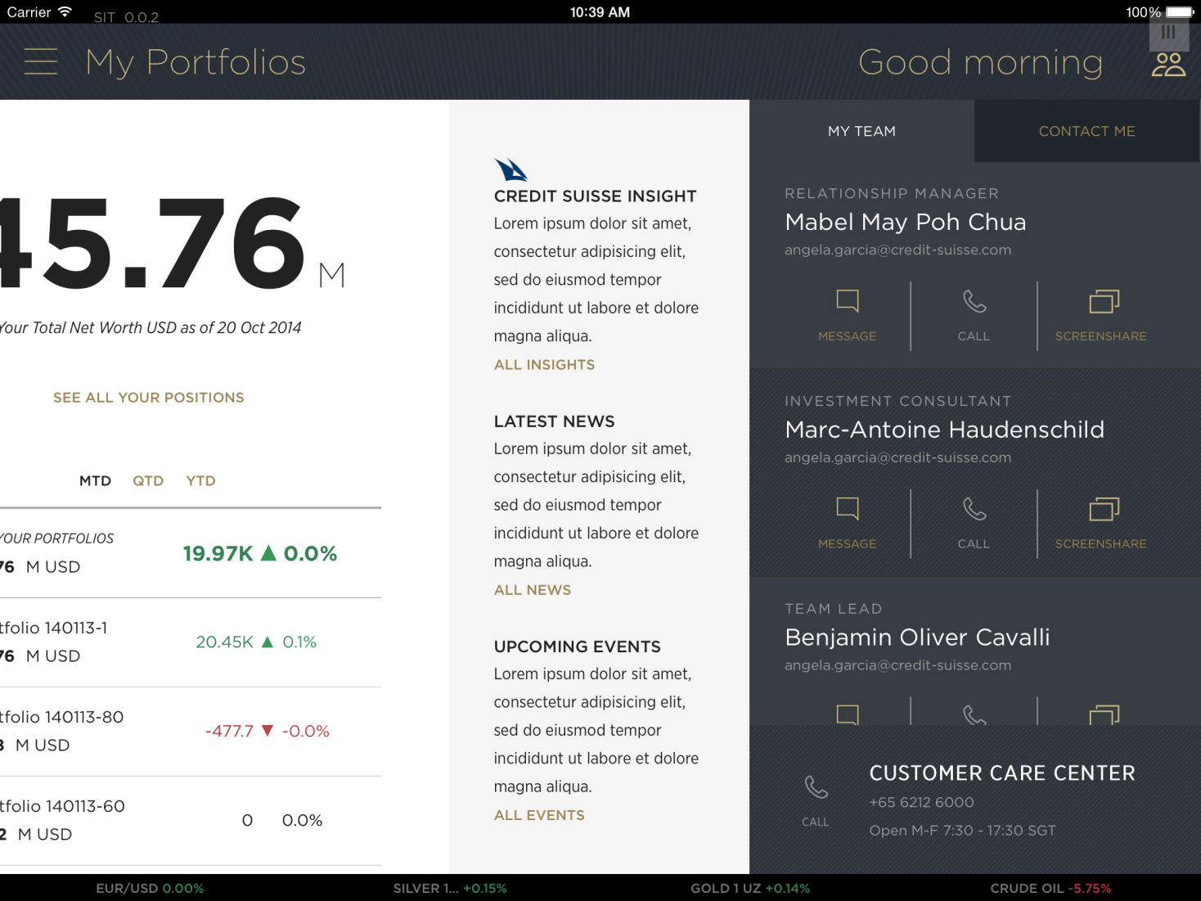

This page verifies:

|  |  |
| --- | --- |
| **Systems / JAP Components** | **Verifications** |
| DPX (Collab) | CifPiD.json |
| BL1 (Collab) | Employee.json |
| BL1 (CRM / Workflow) | ClientContactRequest.json |
|  |  |
|  |  |

# Collab – Screen Sharing with Cafex

## Client Side

1. Initiate screen sharing in the App
2. Accept the pop-up

## RM Side

Start the RMC App: <https://dpbrmc-apac.csintra.net/rmc-web/DPB_Collaborations/#/cs?cif=<Cif for that RM>&bu=0058&pid=<RM PID>>

Example:

<https://dpbrmc-apac.csintra.net/rmc-web/DPB_Collaborations/#/cs?cif=1001562&bu=0058&pid=<Urs PID>>

1. RM has to accept the Pop-up and the screen sharing starts with Annotation.
2. RM can then upload a document and share the document for the document sharing

# Logout

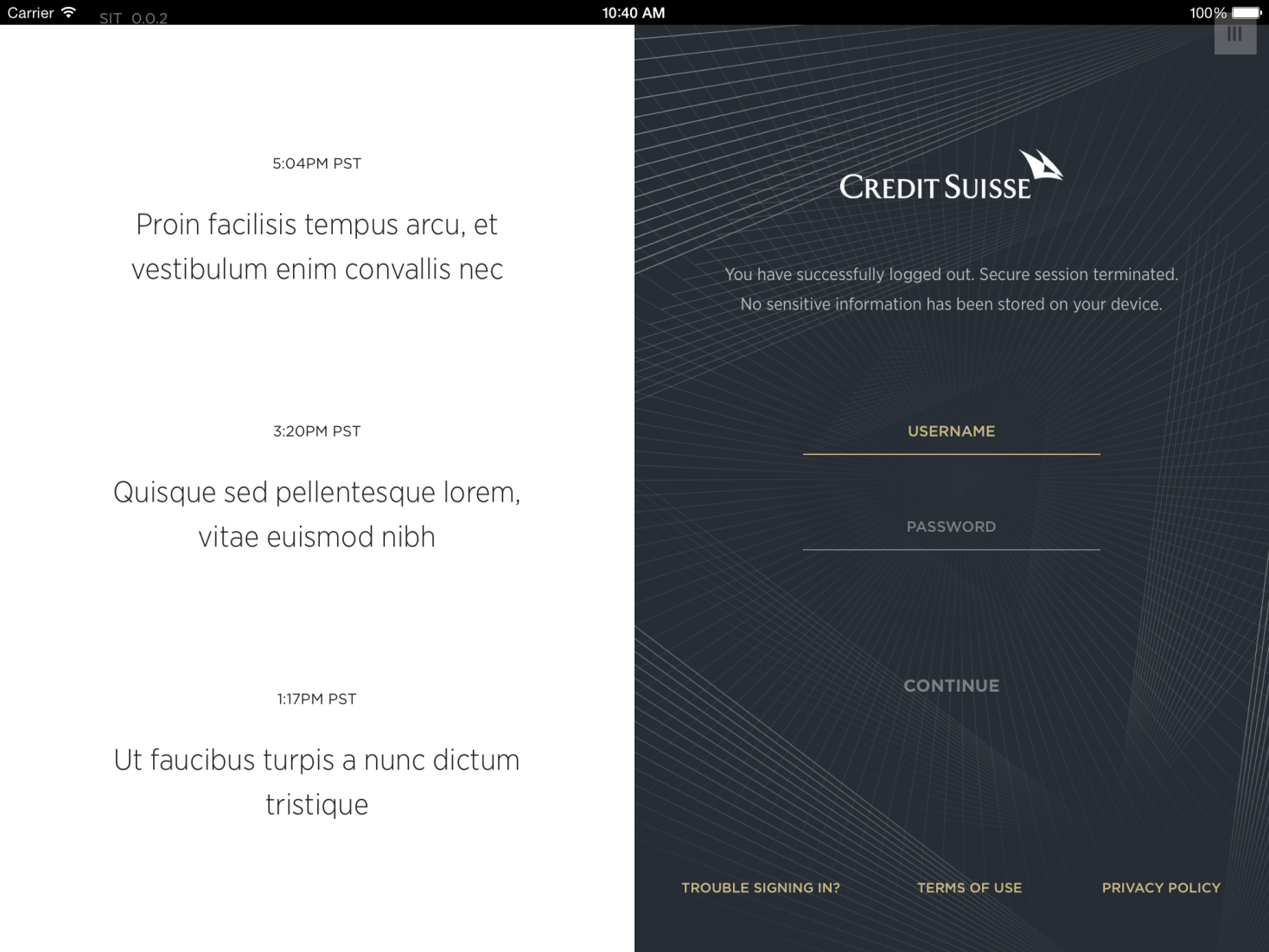

This page verifies:

|  |  |
| --- | --- |
| **Systems / JAP Components** | **Verifications** |
|  |  |
|  |  |
|  |  |
|  |  |
|  |  |

# Auto-logout - Inactivity Period, App in the Background

1. Leave the DPB App w/o any activity and verify that the App logs out automatically
2. Put the App in the background and wait for sometime. Bring the App back to the Foreground and verify that the app is showing the login screen

# Splunk / Analytics

## Web Analytics

Login in to the Splunk Production System and do a filter search by:

host="sgl20030525" OR host="sgl20030526" sourcetype="json_dpb_analytics_v1"

<https://logview.ap.hedani.net>

## Front-End Api log files from JAP

<to be completed>